**CHAPTER 4**

**Comparison of avian guild richness, species abundance, and nest success in   
actively harvested and minimally harvested forested landscapes**

**INTRODUCTION**

**Long-term changes in bird populations**

Prevailing evidence suggests that forest songbird populations in eastern North America have been decreasing in abundance during the past century. Long-term data from annual, nationwide breeding bird surveys indicate that numerous bird species, many of which breed in forests (Robbins et al. 1989), have experienced decreases in their populations throughout the eastern United States since 1966 (Sauer et al. 2020). Additionally, a recent quantitative study using data from multiple and independent monitoring networks demonstrated bird population losses across much of North America since 1970, including a negative change within the range of -15.6% to -19.2% in birds breeding in eastern forests, with 63.5% of those species in decline (Rosenberg et al. 2019).

In the Central Appalachians region of the eastern United States, forest management may contribute to or ameliorate these declines over time, with tradeoffs associated with different forest bird guilds. Bird species that breed in early-successional forest habitat, such as chestnut-sided warblers (*Setophaga pensylvanica*), eastern towhees (*Pipilo erythrophthalmus*), and yellow-breasted chats (*Icteria virens*), are strongly associated with herbaceous or shrubby areas in the stand initiation / stand establishment or regeneration phase, with low canopy basal area (Sheehan et al. 2014). In contrast, bird species that breed in mature forest habitat, such as blue-headed vireos (*Vireo* *solitarius*), ovenbirds (*Seiurus aurocapilla*), and wood thrushes (*Hylocichla mustelina*), are associated with late-successional stands in the canopy transition or old-growth / gap dynamics stages, with high canopy basal area (Sheehan et al. 2014). However, a subset of songbirds that breed in mature forest will shift their habitat use to early-successional areas, including regenerating clear-cuts (Vitz and Rodewald 2006, McDermott and Wood 2010, Streby et al. 2011, Major and Desrochers 2012, Stoleson 2013) during the post-breeding period (i.e., after nesting but before migration) (Pagen et al. 2000, Bowen et al. 2007, Chandler et al. 2012). Thus, there are differential benefits to early-successional vs. mature forest birds when forest management actions such as timber harvest alter the composition and configuration of forested landscapes. Here, landscape composition refers to amount of different habitat patch types without regard to spatial attributes (e.g., proportions of individual habitat types), whereas landscape configuration refers to spatial characteristics of individual habitat patches, requiring spatial information and usually aggregated across patches (e.g., mean patch size, patch density, edge density).

Historically, changes in forested landscapes of the eastern United States over hundreds of years have comprised a loss of old-growth forests followed more recently by a decrease in age-class diversity and structural complexity within second-growth forests (e.g., Schulte et al. 2007) and loss of early-successional habitats dominated by grass, shrubs, or young trees (Askins 2001, Trani et al. 2001). Concomitantly, there have been severe and widespread population declines in shrubland-dependent species (Litvaitis 1993, Hunter et al. 2001, DeGraaf and Yamasaki 2003), with the removal of early-successional habitat from the landscape thought to be the primary reason driving those trends (Kelley et al. 2008). Thus, optimizing diversity across forest-associated bird guilds during the breeding and post-breeding seasons likely calls for mosaic landscapes that contain a variety of forest age classes or successional stages (Loehle et al. 2005, Mitchell et al. 2008). Such landscapes can be produced by active forest management involving timber harvest.

**Timber harvest as a forest management tool for bird conservation**

Timber harvest can be used as a landscape-level forest management tool by increasing the variation in composition and configuration of forested landscapes. For instance, harvesting forests can lead to patches that are distinct, more fragmented, less connected, and smaller (Boucher et al. 2015). These forests also contain more edge area and are subjected to more frequent and more severe uniformly-sized disturbance from periodic, repeated timber harvest regimes. Within stands, even-aged silvicultural systems (e.g., clear-cuts) can create homogenous vertical and horizontal structure (Kuuluvainen et al. 1996), but at a landscape scale, timber rotation length can change the age-class distribution of forests, increasing the proportions of early-successional or young forest (Hejl et al. 1995). In contrast, non-harvested forested landscapes (i.e., no timber harvest within >80 years) are usually characterized by occasional large-scale disturbances and frequent small-scale disturbances, which allow for a finer-grained mosaic of different successional phases (Bengtsson et al. 2000). Thus, landscape-scale structural heterogeneity is generally higher in harvested forests managed in an even-aged system whereas within-stand structural heterogeneity might be higher in non-harvested landscapes (Dettki and Esseen 1998), particularly those subject to historic natural disturbance regimes (e.g., fire). However, century-long fire suppression tactics have reduced the amount of large-scale natural disturbances in forests of eastern North America, contributing to an increase in homogenous forest conditions over large scales. In the absence of natural disturbance regimes, timber harvest may be the most feasible source of anthropogenic disturbance for land managers to diversify forest structure.

Timber harvests can increase the availability of early-successional forest habitat, which leads to increased abundance and densities of early-successional and generalist bird species in those areas (King and Degraaf 2000, Duguay et al. 2001, McDermott and Wood 2009). Similarly, higher proportions of early-successional habitats in harvested landscapes can also result in significantly higher abundances of early-successional and generalist bird species in those landscapes (Drapeau et al. 2000). Timber harvests can also increase fragmentation, edge density, and canopy openings within a forest stand or landscape, which could lead to increased abundance of edge-associated species, such as indigo buntings, and gap-dependent species, such as hooded warblers (Greenberg and Lanham 2001). On the other hand, large-scale timber harvest operations may negatively affect mature forest birds that require intact forest-interior / core forest habitat or late-successional (i.e., >80 years old) forest (Lichstein et al. 2002). Forest-interior species are more abundant in mature forest than clearcuts (King and Degraaf 2000, Sheehan et al. 2014) and in landscapes with higher amounts of late-successional forest in the landscape (Lichstein et al. 2002). Thus, abundance of forest-interior and interior-edge species can decrease after reaching specific thresholds in timber harvest within forested landscapes (Becker et al. 2011). Small openings may not necessarily adversely affect mature forest birds (e.g., Greenberg and Lanham 2001), but a study of the breeding bird community in a Vermont hardwood forest found that 0.4-ha clearcuts resulted in the movement of several forest-interior species away from the harvested areas and subsequently decreased abundance in and adjacent to clearcuts (Germaine et al. 1997).

In addition to species abundance, it is critical to consider long-term bird population dynamics because abundance and density metrics alone can be poor indicators of habitat quality (Van Horne 1983, Vickery et al. 1992, Hagan et al. 1996). Reproductive success of avian species in forested landscapes can be affected by timber harvest due to changes in habitat composition and configuration. For example, nest success of wood thrush in the Monongahela National Forest in West Virginia was found to be positively related to mean shape indices and mean patch fractal dimension of mature forest (both indicative of higher complexity of mature forest patch shapes) and negatively related to an interspersion-juxtaposition index (i.e., measure of the relative interspersion of mature forest patches) and proportion of open habitat (Williams 2002). Composition within forested landscapes further influences avian nesting success by altering interactions between nest predators and nesting birds (Rodewald and Yahner 2001, Rodewald et al. 2001). However, recent studies of nest success within Central Appalachian forests have found little overall effect of various harvest types on productivity (Duguay et al. 2001, Becker et al. 2011, 2012), perhaps because habitat features related to nest survival are spatially variable (Boves et al. 2013*a*, *b*).

Avian population and community processes operate across a broad scale (Bennett et al. 2004), and habitat-associated guilds are thought to respond differently to landscape-scale harvest intensity. Patterns of bird species composition and diversity are related to landscape composition, such as proportions of forest types and ages (Drapeau et al. 2000, Carrara et al. 2015), and landscape configuration, such as patch sizes and edge density. In general, greater landscape age heterogeneity produced by higher levels of timber harvest intensity is associated with greater overall species richness (Loehle et al. 2005, Mitchell et al. 2008). Furthermore, landscape changes due to timber harvest can ultimately result in shifts in avian community composition and diversity (Parody et al. 2001, Anderson and Crompton 2002), as conversion of guild-specific preferred habitat to less suitable habitat can lead to reductions in guild richness (Aratrakorn et al. 2006, Zurita et al. 2006) and increased edge habitat can result in increases in generalist richness but decreases in specialist species richness (Jones et al. 2000). In summary, landscape-scale harvest intensity may differentially affect forest bird assemblages.

**Knowledge gap**

Forest managers often aim to balance or combine the economic benefits of timber harvest with the maintenance of wildlife habitat, biodiversity, and ecosystem function. Forest songbirds exhibit varying responses to timber harvest, which can alter forest composition, configuration, and connectivity on a landscape scale (e.g., Spies et al. 1994). Thus, timber harvest can be potentially used as a landscape-level management tool to promote both early-successional and mature forest songbird populations and diversity (Petit et al. 1995). However, we have an incomplete understanding of how birds respond over time to landscape-scale harvest intensity. Many studies on this topic are traditionally focused on single harvest types or single harvesting events; examine avian responses at control and harvested sites on limited spatial scales; or tend to be short-term (i.e., lasting 1–3 years) and focused on immediate impacts that may not reflect the full temporal response to the management practices under study (Sallabanks et al. 2000, Loehle et al. 2005). By quantifying long-term, landscape-level trends in avian responses to active forest management using multiple harvesting methods and harvesting events (e.g., Perry et al. 2018, Kellner et al. 2019), we can guide management decisions and make recommendations to provide lasting benefits to forest bird species. Thus, it would be valuable to investigate the response of bird communities and populations through time in forested landscapes with varying levels of timber harvest intensity, particularly within the Central Appalachians region.

**Purpose, objectives, and hypotheses**

The purpose of this study was to quantify long-term avian responses to landscape-scale forest management and compare changes over time in avian diversity, abundance, and population dynamics from two Central Appalachian forested landscapes that varied in timber harvest intensity. My specific objectives were to examine the influence and effect of interactions between time and landscape-level timber harvest intensity on breeding season songbird guild richness, focal species abundance, and focal species nest success. I focused on 2 landscapes with diverging forest management prescriptions: (1) an actively harvested landscape with >60% of its area experiencing diameter-limit harvest, two-age harvest, or clear-cutting during the study period (1993–2009), and (2) a minimally harvested landscape with <1% of its area experiencing two-age harvest or clear-cutting approximately 10–15 years prior to the study period.

In this study, I tested the hypothesis that long-term temporal trends in forest songbird communities and populations during the breeding season are mediated by landscape-level forest management. I predicted that trends over time in diversity, abundance, and nest success would vary by guild designation and landscape (i.e., level of timber harvest intensity). For example, in the actively harvested landscape, I expected that early-successional / edge-associated species would respond positively over time, whereas forest-interior and forest-gap species would respond negatively over time. In contrast, in the minimally harvested landscape, I expected that early-successional / edge-associated species would respond negatively over time, while forest-interior and forest-gap species would show little to no response. Taking a holistic approach, I assessed the statistical significance and effect sizes of interactions between time and landscape-level timber harvest intensity for overall species richness, the number of species belonging to 4 habitat guild designations, the abundance of 15 focal songbird species, and the nest success of 6 focal songbird species (Table 1).

**METHODS**

**Study area**

Sampling points and nest search plots for this study were spread throughout 2 study areas within the Central Appalachians region (Figures 1–3). I used data from a total of 1,186 sampling points and 50 nest search plots (Figures 2–3), consisting of 166 sampling points and 20 nest search plots in the actively harvested MeadWestvaco Wildlife and Ecosystem Research Forest (WERF), which is located in Randolph County, West Virginia, and 1020 sampling points and 30 nest search plots in the minimally harvested Monongahela National Forest (MNF), which encompasses portions of nine counties (Preston, Tucker, Grant, Randolph, Pendleton, Pocahontas, Webster, Nicholas, and Greenbrier) in eastern West Virginia. All sampling points used in this study were located in forest stands that experienced varying levels and types of recent or ongoing timber harvest (ranging from no harvest to clear-cutting), and distances between sampling points were at least 200 m.

Research in the actively harvested WERF was conducted from 1996–1998 (Weakland 2000), 2001–2003 (Dellinger 2005), and 2007–2009 (Becker 2010). The WERF encompasses 3,080 ha and was established in 1994 by the Westvaco Corporation to study the effects of industrial forest management practices on ecosystem processes and wildlife within a primarily 70–90 year-old even-aged mature forest. Located within the Central Appalachians (Allegheny Mountains) physiographic province, regional topography within the WERF consists of narrow valleys with small, high-gradient streams and broad ridges oriented south-southwest to north-northeast (Becker et al. 2011). Annual average precipitation is >160 cm per year (Strausbaugh and Core 1977), and elevation ranges 734–1,180 m. Vegetation communities in the WERF are variable across that elevational gradient. At high elevations (>1,000 m), red spruce (*Picea rubens*) and eastern hemlock (*Tsuga canadensis*) dominate. At mid-elevations (850–1,000 m), northern hardwoods such as red maple (*Acer rubrum*), American beech (*Fagus grandifolia*), and black cherry (*Prunus serotina*) are most prevalent. Meanwhile, low-elevation sites (<850 m) consist of cove hardwood and mixed mesophytic plant communities (northern red oak [*Quercus rubra*], black birch [*Betula lenta*], and tulip-poplar [*Liriodendron tulipifera*]) and xeric oak-hickory communities (black oak [*Quercus velutina*], scarlet oak [*Q. coccinea*], and hickory [*Carya* spp.]). Non-forest cover in the study area was limited to grassy cover along road edges, gas well openings, and log landings.

Research in the minimally harvested MNF was conducted from 1993–1994 (Nichols 1996), 1995–1996 (Duguay 1997), 1996–1997 (DeMeo 1999), 1998–2000 (Williams 2002), and 2001–2009. The MNF was placed under federal protection in 1920 and encompasses nearly 688,000 ha, of which 54% (371,906 ha) is owned and overseen by the U.S. Forest Service. The MNF stretches across a latitudinal range of nearly 200 km and lies within two physiographic provinces, the Central Appalachians (Allegheny Mountains) and the Ridge and Valley. The eastern section of the Monongahela National Forest, which overlaps the Ridge and Valley physiographic province, lies in the rain shadow of the Allegheny Mountains, so it receives significantly less precipitation (~75 cm/year) compared to the rest of the forest, which experiences 115–150 cm/year (Clarkson 1966). Elevation within the MNF ranges 275–1,480 m. In terms of forest composition, the MNF was comprised primarily of 70–100 year-old stands at the start of the study period, with high regional tree diversity and 4 major forest zones (mixed mesophytic, northern hardwoods, red spruce, and dry oaks) (McCay et al. 1997, DeMeo 1999). Mixed mesophytic forests are present at low elevations (<900 m), with northern red oak, sugar maple (*Acer saccharum*), hickory, and tulip-poplar as the dominant species (Madarish et al. 2002). At increasing elevations, there is a transition in stand dominance to northern hardwoods, including American beech, sugar maple, and black cherry (*Prunus serotina*) (Stephenson 1993). At the highest elevations (>1,150 m), remnant boreal forest ecosystems consist of red spruce. In the eastern MNF, dry oaks are common in the Ridge and Valley area, consisting of white (*Q. alba*), chestnut (*Q. prinus*), scarlet, and black oaks, as well as pines (*Pinus* spp).

**Harvest history**

During its establishment in 1994, the WERF was comprised of secondary forests that were established by natural regeneration following large-scale logging from 1916–1928 (Keyser and Ford 2005). Timber had been sporadically thinned and harvested since the 1930’s, resulting in numerous logging roads and skidder trails transecting the forest. Since its initial establishment, much of the WERF had been actively managed using even-aged timber harvesting through clear-cuts, shelterwood cuts, and uneven-age or partial harvesting via single-tree selection and high-grade harvests of mature sawtimber (Dellinger et al. 2007). Prior to 1997, several timber harvests had been conducted, including diameter-limit harvests, two-age harvests, and regeneration (seed-tree) harvests, but the majority of the WERF remained mature deciduous or mixed forest (Figure 4). From 1997–1998, additional forest stands were harvested using a variety of methods (e.g., diameter-limit harvests, two-age harvests, regeneration harvests, clear-cuts). More stands were harvested throughout the years, and nearly 50% of the WERF had recently experienced some type of harvest by 2003 (Figure 4). In 2007, management shifted to primarily uneven-aged techniques, and by 2009, at least 60% of the WERF had been recently harvested to some degree (Figure 4). Thus, the WERF served as an actively harvested landscape for this study.

The MNF is comprised of mature, second-growth Appalachian hardwood forests. A timber harvest rotation of 100–120 years applies to most areas of the MNF not designated as Wilderness Areas, and the vast majority of the MNF had not been harvested nor majorly disturbed within 50 years prior to the study period. Therefore, most of the sampling points within the MNF were located in relatively intact areas with high (>60%) core area (DeMeo 1999). A small subset of the sampling points was in forest stands in the Cheat and Greenbrier Ranger Districts of the MNF that had experienced two-age harvest or clear-cutting between 1979 and 1986 for a study on the effects of two-age harvests (Miller et al. 2006). However, the area of the harvested stands accounted for <1% of the total area of public lands in the MNF. Thus, the MNF served as a minimally harvested landscape for this study.

**Guild designations**

To compare temporal trends for overall species richness and guild richness in the actively harvested landscape and the minimally harvested landscape, I considered a subset of the 114 total avian species that were detected across all surveys in all years from the 2 study areas. Specifically, I limited the richness analyses to 62 passerine and near-passerine species (see Appendix A for full list) with breeding ranges that encompassed the 2 study areas and that had ≥10 detections. I also excluded wetland-associated songbirds (e.g., red-winged blackbirds [*Agelaius phoeniceus*]) because they were incidental to the focal habitat types, as well as corvids and waterthrushes because they are not well-sampled with breeding songbird point count surveys.

Habitat-related guild designations for the 62 songbird species were assigned based on breeding habitat and comprised 4 categories (Appendix A): (1) early-successional / edge-associated (i.e., primarily breed or found in grasslands, shrub/scrub, or young forest; or along forest edges, such as the interface of early-successional and mature forest); (2) forest-interior (i.e., generally breed or found in the core area of mature forest); (3) forest-gap (i.e., generally breed or found in or near small forest gaps within the core area of mature forest); and (4) forest generalist (i.e., associated with forest but no preference for early-successional vs. mature forest).

**Focal species**

To compare temporal trends in focal species abundance in the actively harvested landscape and the minimally harvested landscape, I selected a total of 15 songbird species across the 4 guild designations (Table 1): 4 early-successional / edge-associated species, 4 forest-interior species, 4 forest-gap species, and 3 forest generalist species. Species selection was based on relative frequency; for each guild designation, I included the 3 species with the highest relative frequency. For the early-successional / edge-associated guild, forest-interior guild, and forest-gap guild, I additionally included a species of regional conservation concern with the highest relative frequency.

To assess temporal trends in focal species nest success in the actively harvested landscape and the minimally harvested landscape, I selected 6 species from the 15 songbird species listed above as focal species for abundance analyses (Table 1): 2 early-successional / edge-associated species, 3 forest-interior species, and 1 forest-gap species. Species selection was based on sample size; these were the 6 species that had sample sizes of at least 70 total nests across the 2 study areas and a minimum of 15 nests from each study area.

**Bird count data**

Avian point count survey data for the 2 study areas were collected in 1996–1998, 2001–2003, and 2007–2009 at 166 WERF sampling points and in 1996–2009 at 1020 MNF sampling points. In the WERF, point count surveys were conducted within a 50-m fixed radius at locations selected systematically from available points on a 241 x 241 m forest inventory grid (Figure 2) established in 1995 by Westvaco Forest Resources (prior to extensive timber harvesting). An average of 110 points were surveyed each year, and locations were mostly consistent across time periods. In the MNF, point count surveys were conducted along 109 extensive linear transects (up to 2,500 m in length) with 10–12 sampling points per transect (Figure 3). Of the 109 total transects, at least 44 transects were oriented at right angles to contours to capture maximum variation in elevation and landforms.

Avian point count surveys were not completed every year at every sampling point. The number of years of data associated with each sampling point ranged 2–9 years (mean = 5.9 ± 2.5 years) in the WERF and 1–12 years (mean = 4.0 ± 2.8 years) in the MNF. Within a year that avian point count survey data were collected, the number of repeated visits (i.e., replicate surveys) ranged from 1–3 visits (mean = 2.0 ± 0.2 visits) in the WERF and 1–4 visits (mean = 1.3 ± 0.5 visits) in MNF. I included all replicate surveys per sampling point per year in my data analyses, for a total of 14,504 replicate surveys across 4,999 site × year combinations.

At both study areas, avian point count surveys were conducted from mid-May to early July (i.e., during the bird breeding season) and consisted of 10-minute stationary counts, during which a single observer recorded all individuals heard or seen. Up to 4 detection covariates were recorded for each survey: date, start time, wind code, and sky code. While date was recorded for all surveys, a subset of surveys was missing start times (68% of MNF data), wind codes (73% of MNF data), or sky codes (73% of MNF data). However, all surveys began within 30 minutes of sunrise and continued until approximately 4 hours after sunrise, and no surveys were conducted on days with rain, heavy fog, or high wind speed, following the guidelines of Ralph et al. (1993).

The 10-minute point count survey was divided into 2 time intervals (i.e., within-survey replicates): 0–5 minutes and >5–10 minutes. Individual birds were only recorded the first time they were observed, following removal sampling methods. For each record, observers indicated the corresponding time interval and distance band (≤50 m or >50 m). To limit detection variability due to distance, I restricted all data analyses to birds detected within 50 m.

**Nest success data**

Avian nest monitoring survey data were collected at the 2 study areas from 1996–1998, 2001–2003, and 2007–2009 from 20 WERF nest search plots and from 1993–1999 at 30 MNF nest search plots (Figures 2–3). Throughout the breeding season, field technicians looked for active nests within the nest search plots. Nests that were located through both systematic searching efforts and opportunistic observations were then monitored from mid-May until mid-July. During the monitoring period, field technicians checked each nest a minimum of every 3–4 days until the nesting attempt was complete and identified as either successful or failed. From the nest monitoring records, I used the following data for each nest location: bird species, success or failure during the incubation period, and success or failure during the brooding period.

Nest search plots varied in size and location among sampling years and between study areas (Figures 2–3). In the WERF, there were 8 45-ha nest search plots during 1996–1998 and 12 20-ha nest search plots during 2001–2003 and 2007–2009. The nest search plots were distributed randomly throughout 3 elevational blocks and encompassed either non-harvested areas with intact, predominantly mature hardwood forest, lightly harvested areas that retained closed canopy conditions, or heavily harvested areas with early-successional vegetation. Due to harvest activity, 4 nest search plots had to be shifted slightly for the 2007–2009 nest monitoring seasons (Figure 2). In the MNF, 31 stands were intensively searched for nests during 1993–1998 (Duguay et al. 2001), with search effort distributed relatively evenly between stands. From 1996 to 1999, nest searches occurred within 40-ha (200-m wide × 2,000-m long, oriented perpendicular to prevailing slopes) plots that were established along 2 transects in each of 5 2,500-ha study areas that were randomly located within the mixed mesophytic vegetation zone of the MNF; the study areas ranged from 42–81% in core forest area (DeMeo 1999). Nest searching protocols followed the methodology of the national BBird program of nest search plot monitoring (Conway and Martin 2000). In 1998 and 1999, additional nests (outside the established nest search plots) in the northwestern region of the MNF (within Tucker and Randolph counties) were located through behavioral cues and systematic searches of likely nesting habitat (Williams 2002).

My objective was to compare temporal trends in nest success between the actively harvested landscape and the minimally harvested landscape, but the time periods of nest monitoring at the 2 study areas did not fully overlap (WERF: 1996–1998, 2001–2003, and 2007–2009 vs. MNF: 1993–1999). Therefore, I made the following assumptions: (1) trends from MNF data collected from 1993 to 1999 were representative of long-term trends; and (2) there were no outside, unconsidered systemic confounding factors (e.g., stochastic weather extremes, climate change, invasive species introduction) influencing trends from WERF data collected after 1999.

**Environmental data**

The full set of site covariates for the guild richness analyses and focal species abundance analyses included year of data collection, landscape-scale harvest intensity, an interaction between year and landscape-scale harvest intensity, and 15 environmental variables that were included to account for their known effects (Table 2). Landscape-scale harvest intensity was a dummy variable where 1 = actively harvested landscape (i.e., WERF) and 0 = minimally harvested landscape (i.e., MNF). The first 3 controlling environmental variables were topographical factors: elevation, aspect, and topographical position index (TPI). Mean elevation, mode aspect, and mode TPI within 50 m of each sampling point were calculated or derived using Shuttle Radar Topography Mission digital elevation data, which had a resolution of ~20–25 m. The next controlling environmental variable was stand age. To calculate mode stand age within 50 m of each sampling point, I used GIS datasets from the WERF and from the MNF that mapped forest stands in each study area and provided stand-scale attribute information.

The 11 remaining controlling environmental variables involved land cover classifications and were determined using the 2001, 2004, 2006, and 2008 National Land Cover Databases (NLCD), which all have a resolution of 30 m (Jin et al. 2019). All calculations were made using land cover data from the closest year available (i.e., I used the 2001 NLCD data for surveys conducted in 2002 or earlier, 2004 NLCD data for surveys conducted in 2003 or 2004, 2006 NLCD data for surveys conducted in 2005–2007, and 2008 NLCD data for surveys conducted in 2008 or 2009). To account for breeding songbird habitat type, I calculated the proportions of all forest (i.e., any type of mature forest) and of shrub cover within 50 of each sampling point. Mature forest cover was defined as areas dominated by trees generally >5 m tall and >20% of total vegetation cover, and shrub cover was defined as areas dominated by shrubs (i.e., <5 m tall with shrub canopy typically >20% of total vegetation) and included true shrubs and young trees in an early successional stage. To account for forest type, I calculated the proportions of deciduous forest and of conifer forest within 50 m of each sampling point. To account for landscape composition, I included the proportion of all forest and of shrub cover within 1 km of the sampling point, and to account for landscape configuration, I included landscape patch richness (i.e., number of patch types), mean number of core forest patches, forest patch density (i.e., number of forest patches per 100 ha), open habitat patch density (i.e., number of open habitat patches per 100 ha), and total forest edge (sum of all edges of forest patches) within 1 km of the sampling point. I calculated the 5 landscape configuration metrics with the “landscapemetrics” package (Hesselbarth 2023) in Program R (R Core Team 2022), using 4 patch types (Figure 5): mature forest (comprising deciduous, mixed, and coniferous forest), open habitat (representing early-successional habitat and comprising shrubs, grasslands, and hay / pasture), water, and other non-habitat cover (comprising developed land, barren land, and cropland).

**Data analysis**

*Determining overall species and guild richness from a hierarchical community model*

To calculate overall species richness and guild richness at each sampling point in each year sampled, I estimated the individual species occupancy of the 62 passerine and near-passerine species (Appendix A) simultaneously in a hierarchical community model (see Appendix B for JAGS code) and then derived the corresponding sums for all species and each guild designation (Zipkin et al. 2010). The hierarchical community model facilitated a multi-species approach to estimating individual species occurrence probabilities (Dorazio and Royle 2005, Dorazio et al. 2006). Following the modeling framework of Zipkin et al. (2010), species-specific occurrence and detection processes within the hierarchical community model were related to one another through a community-level hierarchical component, which assumed that each of the species parameters were random effects, governed by “hyper-parameters” (i.e., drawn from a community-level distribution). Linking individual species occurrence probabilities through this community-level hierarchical component leads to improved precision of species-specific estimates (Kéry and Royle 2008, Zipkin et al. 2009).

Occurrence *Zs,y,sp* was defined as a binary variable in which *Zs,y,sp* = 1 if species *sp* occurs within 50 m of sampling point *s* in year *y*. The occurrence state was assumed to be the outcome of a Bernoulli random variable, denoted by:

*Zs,y,sp* ~ *Bernoulli*(*Ψs,y,sp*)

where *Ψs,y,sp*is the probability that species *sp* occurs at sampling point *s* in year *y*. I further used a logit link to model relationships between occurrence probability (*Ψs,y,sp*) and 15 site covariates, which consisted of elevation, aspect, TPI, stand age, proportion of all forest / shrub / deciduous forest / conifer forest within 50 m, proportion of all forest / shrub cover within 1 km, landscape patch richness within 1 km, mean number of core forest patches within 1 km, forest / open habitat patch density within 1 km, and total forest edge within 1 km (Table 2). All continuous site covariates were centered and scaled prior to analysis. In addition, the hierarchical community model incorporated a random site effect to account for repeated observations at each sampling point over the course of multiple years.

Given the observed data *Ys,y,r,sp*, where *r* is a within-survey replicate (i.e., 5-minute time interval during the 10-minute point count survey period) across all survey replicates (i.e., repeated visits to the sampling point during the sampling year), I defined the detection model for species *sp* at sampling point *s* in year *y* during replicate *r* as:

*Ys,y,r,sp* ~ *Bernoulli*(*ps,y,r,sp* × *Zs,y,sp*)

where *ps,y,r,sp* is the detection probability of species *sp* for the *r*th replicate at sampling point *s* in year *y*, given that species *sp* is present at sampling point *s* in year *y*. I further used a logit link to model linear relationships between detection probability (*ps,y,r,sp*) and 4 detection covariates, which consisted of ordinal day (centered and scaled prior to analysis), time since sunrise (measured as decimal hours and centered and scaled prior to analysis), a dummy variable for wind (0 = wind codes of 0, 1, or 2; 1 = wind codes >2), and a dummy variable for sky (0 = sky codes of 0, 1, or 2; 1 = sky codes >2). I also incorporated a species-specific random observer effect in the hierarchical community model.

Because a subset of avian point count surveys conducted in the MNF lacked data pertaining to time, wind code, or sky code, I imputed those detection covariate values. I assumed that time since sunrise was a Gaussian random variable, and that the wind and sky dummy variables were Bernoulli random variables. Imputation was informed by the observed data and accounted for uncertainty, with values drawn from a posterior distribution of each detection variable (Gelman et al. 2014).

Ultimately, the hierarchical community model yielded species-specific estimates of latent occupancy (*Zs,y,sp*) for species *sp* at each sampling point *s* in each year *y* based on observed data from replicate surveys. I then derived the overall species richness for each sampling point in each year by summing the occupancy of the 62 passerine and near-passerine species, as in the following equation:

$$\sum_{sp=1}^{62}{Z_{s,y,sp}}$$

Similarly, I derived guild-specific richness by summing the occupancy of the subset of songbird species that belonged to each habitat guild designation (Appendix A).

I constructed the hierarchical community model in a Bayesian framework, implemented with Markov chain Monte Carlo methods. For all community-level and species-specific parameters, I used prior distributions which were meant to provide little information; all gamma prior distributions, often used for variance parameters, had a shape parameter of 0.1 and rate parameter of 0.1, and all Gaussian prior distributions, such as for the community-level slope coefficients for each site covariate, had a mean of 0 and precision of 0.01 (Appendix B). I fit the models in JAGS (Plummer 2003) using the “jagsUI” package (Kellner and Meredith 2021) in Program R (R Core Team 2022). I used the “jags” function to run 3 chains of 7,000 iterations for the hierarchical community model, with a burn-in of 5,000 iterations and thinning rate of 2 iterations, which resulted in 3,000 posterior draws and reasonable convergence (R̂ ≤ 1.1) (Gelman et al. 2014).

*Determining relationships with harvest intensity over time for overall species and guild richness*

After I derived detection-corrected overall species and guild richness from the hierarchical community model, I then incorporated those estimates into corresponding generalized linear mixed effects models, with overall species or guild richness as the response variable and incorporating an interaction between time and landscape-level harvest intensity as a predictor variable. To propagate uncertainty from the original hierarchical community model results, I ran 3,000 iterations of the generalized linear mixed effects models for overall species richness and for each guild designation, cycling through the values from each of the 3,000 posterior draws. In result, the models yielded a posterior distribution of 3,000 for each slope coefficient, from which I derived the mean and 95% credible intervals. Thus, the estimated effects on overall species and guild richness were calculated as derived quantities (Kery and Royle 2016).

For each generalized linear mixed effects model, I assumed the number of species at each site in each year (i.e., overall species richness or guild richness) to be a Poisson random variable and used a log link to model relationships with controlling topographical / habitat / landscape factors and an interaction between year and landscape-level harvest intensity. All continuous predictor variables were centered and scaled prior to analysis. The total number of slope coefficients was 20 (resulting in a ratio of ~250 site × year combinations to 1 slope coefficient; Bolker et al. 2008), corresponding to year, landscape-level harvest intensity, year × landscape-level harvest intensity, elevation, aspect, aspect squared, TPI, stand age, stand age squared, proportion of all forest within 50 m, proportion of shrub within 50 m, proportion of deciduous forest within 50 m, proportion of conifer forest within 50 m, proportion of all forest within 1 km, proportion of shrub within 1 km, landscape patch richness within 1 km, mean number of core forest patches within 1 km, forest patch density within 1 km, open habitat patch density within 1 km, and total forest edge within 1 km. All of the generalized linear mixed effects models also incorporated a random site effect for log expected richness to account for repeated observations at each sampling point over the course of multiple years.

I fit all generalized linear mixed effects models using the “lme4” package (Bates et al. 2015) in Program R (R Core Team 2022). Specifically, I used the “glmer” function with family = “poisson”, optimizer = “bobyqa” (i.e., a specific optimizing function used by the model), and nAGQ = 0. The nAGQ is the number of points per axis for evaluating the adaptive Gauss-Hermite approximation to the log-likelihood. A value of zero uses a form of parameter estimation for generalized linear mixed effects models by optimizing the random effects and the fixed-effects coefficients in the penalized iteratively reweighted least squares step.

*Determining relationships with landscape-level harvest intensity over time for abundance of individual focal species*

To quantify and compare temporal trends in the abundance of specific focal species during the breeding season, I estimated the abundance of 15 songbird species (Table 1) independently in stacked N-mixture models (Royle 2004) (see Appendix C for JAGS code). For the abundance model within the hierarchical stacked N-mixture model, I assumed that species count was a Poisson random variable and used a log link to model relationships with controlling topographical and habitat factors and an interaction between year and landscape-level harvest intensity. All continuous predictor variables were centered and scaled prior to analysis. The total number of slope coefficients was 20 (resulting in a ratio of ~250 site × year combinations to 1 slope coefficient), corresponding to same site covariates as for the generalized linear mixed effects models. The stacked N-mixture models also incorporated a random site effect for log expected count to account for repeated observations at each sampling point over the course of multiple years.

For the detection model within the hierarchical stacked N-mixture model, I assumed that the observed count was a binomial random variable and modeled the probability of detection for each within-survey replicate, using the same methods as for the hierarchical community model. I further used a logit link to model linear relationships between detection probability and 4 detection covariates, which consisted of ordinal day (centered and scaled prior to analysis), time since sunrise (measured as decimal hours and centered and scaled prior to analysis), a dummy variable for wind (0 = wind codes of 0, 1, or 2; 1 = wind codes >2), and a dummy variable for sky (0 = sky codes of 0, 1, or 2; 1 = sky codes >2). I used the same methods as for the hierarchical community model to impute study region-specific detection covariates for avian point count surveys from the MNF that were lacking data on time, wind code, or sky code.

The stacked N-mixture models were constructed in a Bayesian framework, implemented with Markov chain Monte Carlo methods. For all model parameters, I used prior distributions which were meant to provide little information; gamma prior distributions had shape and rate parameters of 0.01 or 0.1, and Gaussian prior distributions had a mean of 0 and precision of 0.01 (Appendix C). I fit the models in JAGS (Plummer 2003) using the “jagsUI” package (Kellner and Meredith 2021) in Program R (R Core Team 2022). I used the “autojags” function to run 3 chains for each model with a burn-in of 9,000–54,000 iterations (Appendix D), thinning rate of 3 iterations, and iteration increment of 3,000; models iteratively ran until reasonable convergence (R̂ ≤ 1.1) was achieved (Gelman et al. 2014), resulting in 3,000–9,000 posterior draws.

*Determining relationships with harvest intensity over time for nest success of individual focal species*

To quantify and compare temporal trends in nest success of specific focal species during the breeding season, I estimated the overall probability of nest success of 6 songbird species (Table 1) independently in conditional binomial models (see Appendix E for JAGS code). I assumed that observed nest success was a Bernoulli random variable and modeled both the probability of nest success during the incubation period and the probability of nest success during the brooding period, which was conditional upon nest success during the incubation period. Thus, given the observed nest success data *Ys,sp,1:2*, where *Ys,sp,1* = 1 if the nest of species *sp* at nest location *s* survived the incubation period (and *Ys,sp,1* = 0 if not) and *Ys,sp,2* = 1 if the nest of species *sp* at nest location *s* survived the brooding period and successfully fledged at least 1 offspring (and *Ys,sp,2* = 0 if not), I defined the nest success model as:

*Ys,sp,1* ~ *Bernoulli*(*p.incubations,sp*)  
*Ys,sp,2* ~ *Bernoulli*(*p.broodings,sp* × *Ys,sp,1*)

where *p.incubations,sp* is the probability of nest success during the incubation period and *p.incubations,sp* is the probability of nest success during the brooding period, dependent upon the nest fate during the incubation period. The probability of overall nest success (*p.overalls,sp*) for species *sp* at nest location *s* was then calculated as the product of the probabilities of nest success during the incubation and brooding periods, as in the following equation:

*p.overalls,sp = p.incubations,sp* × *p.broodings,sp*

For both the probabilities of nest success during the incubation and brooding periods, I further used a logit link to model their relationships with 4 site covariates, which consisted of year, landscape-level timber harvest intensity, a dummy variable for harvest history within the nest search plot (0 = no timber harvest within the past 20 years; 1 = some type of timber harvest within the past 20 years), and a dummy variable for whether the nest search plot was dominated (i.e., >50%) by mature forest (0 = no; 1 = yes). The total number of slope coefficients was 5 (resulting in a ratio of 14–50 nest locations to 1 slope coefficient), corresponding to year, landscape-level harvest intensity, year × landscape-level harvest intensity, harvest history, and mature forest. I also incorporated a species-specific and period-specific random nest search plot effect in the conditional binomial model.

The conditional binomial models were constructed in a Bayesian framework, implemented with Markov chain Monte Carlo methods. For all model parameters, I used prior distributions which were meant to provide little information; gamma prior distributions had shape and rate parameters of 0.01, and Gaussian prior distributions had a mean of 0 and precision of 0.01 (Appendix E). I fit the models in JAGS (Plummer 2003) using the “jagsUI” package (Kellner and Meredith 2021) in Program R (R Core Team 2022). I used the “autojags” function to run 3 chains for each model with a burn-in of 9,000–30,000 iterations (Appendix D), thinning rate of 3 iterations, and iteration increment of 3,000; models iteratively ran until reasonable convergence (R̂ ≤ 1.1) was achieved (Gelman et al. 2014), resulting in 6,000 or 9,000 posterior draws.

*Determining significance of interactions*

For all of the guild richness models, focal species abundance models, and focal species nest success models, relationships with individual linear variables were considered significant when the 95% credible intervals of their slope coefficient values did not overlap zero (Tables 3–4, Figures 5–7). Similarly, interactions between year and landscape-scale harvest intensity were considered significant when the 95% credible intervals of their effective slope coefficient values did not overlap zero (Tables 5–6, Figures 8–10). I defined an annual effective slope coefficient for landscape-scale harvest intensity as the effect of a 1-unit change in the dummy variable (representing the difference between the actively harvested landscape [1] and the minimally harvested landscape [0]) corresponding to each year in the study period. For year, I defined an effective slope coefficient as the effect of a 1-unit change in time given specific levels of landscape-scale harvest intensity (i.e., actively harvested landscape vs. minimally harvested landscape). Given the following equation:

*Y* = *β0* + *β1* × *X1* + *β2* × *X2* + *β3* × *X1* × *X2*

where *X1* is year (scaled and centered), *X2* is landscape-level harvest intensity (either 0 or 1), and all the other variables are held constant at their mean values, then the annual effective slope coefficient (*βeff*) for landscape-scale harvest intensity can be calculated as *βeff* = *β2* + *β3* × *X1* and the effective slope coefficient (*βeff*) for year can be calculated as *βeff* = *β1* + *β3* × *X2*.

**RESULTS**

**Effects of harvest intensity over time on overall species and guild richness**

Guild richness model results indicated a significant interaction between year and landscape-scale harvest intensity for overall species richness and early-successional / edge-associated guild richness, forest-interior guild richness, and forest-gap richness (Table 3). Looking at the annual effective slope coefficients for landscape-scale harvest intensity, mean expected richness was generally higher in the actively harvested landscape (Figure 9), but the guilds exhibited distinct temporal trends (Table 5). Overall species richness and forest-interior guild richness were significantly higher in the actively harvested landscape for the entire study period, but early-successional / edge-associated richness and forest-gap guild richness were significantly higher in the actively harvested landscape following a lag of 4 years after the start of the study. Meanwhile, forest generalist guild richness was only significantly higher in the actively harvested landscape during the final 2 years of the study period (2008–2009).

Looking at the effective slope coefficients for year, trends in overall species richness and guild richness over time seemed to be increasing in the actively harvested landscape and decreasing in the minimally harvested landscape (Table 6, Figure 9). Overall species richness and forest-gap guild richness showed significant changes in both landscapes. The effective slope coefficients for year indicated significant increases in early-successional / edge-associated guild richness over time in the actively harvested landscape, whereas forest-interior guild richness was significantly decreasing over time in the minimally harvested landscape. Forest generalist guild richness did not exhibit a significant change over time at either level of landscape-scale harvest intensity.

**Effects of harvest intensity over time on focal species abundance**

Focal species abundance model results indicated a significant interaction between year and landscape-scale harvest intensity for 7 of the 15 total focal songbird species, including 1 of the 4 early-successional / edge-associated species, 3 of the 4 forest-interior species, 2 of the 4 forest-gap species, and 1 of the 3 forest generalist species (Table 3). Looking at the annual effective slope coefficients for landscape-scale harvest intensity, mean expected abundance was generally higher in the actively harvested landscape (Figure 10), but there was temporal variation in significance (Table 5). The expected abundance of 4 species (chestnut-sided warbler, eastern towhee, dark-eyed junco, and veery) was significantly higher in the actively harvested landscape for the entire study period (1996 –2009), while the abundance of 6 species (indigo bunting, black-throated green warbler, red-eyed vireo, hooded warbler, American robin, and black-capped chickadee) was significantly higher in the actively harvested landscape following a lag of 2-4 years after the start of the study. American redstart and cerulean warbler were the only 2 focal species to have significantly higher mean expected abundance in the minimally harvested landscape for a portion of the study period. Finally, 3 focal species had effective slope coefficients for landscape-scale harvest intensity that were never statistically significant.

Looking at the effective slope coefficients for year, trends in focal species abundance over time seemed to be increasing in the actively harvested landscape and decreasing in the minimally harvested landscape (Table 6, Figure 10). Of the 4 early-successional / edge-associated species, brown-headed cowbird and chestnut-sided warbler abundance was significantly decreasing over time in the minimally harvested landscape, while indigo bunting (*Passerina cyanea*) abundance was significantly increasing over time in the actively harvested landscape, and eastern towhee showed increasing abundance over time in both landscapes, with a higher rate of increase in the actively harvested landscape. Of the 4 forest-interior species and 4 forest-gap species, dark-eyed junco abundance was significantly increasing in the actively harvested landscape and significantly decreasing in the minimally harvested landscape, while black-throated green warbler (*Setophaga virens*), red-eyed vireo, American redstart, and veery (*Catharus fuscescens*) abundance significantly decreased over time in the minimally harvested landscape and hooded warbler (*Setophaga citrina*) abundance significantly increased over time in the actively harvested landscape. Of the 3 forest generalist species, American robin abundance significantly increased over time in the actively harvested landscape, and black-capped chickadee abundance significantly decreased over time in the minimally harvested landscape. Only 3 focal species (wood thrush, cerulean warbler, and white-breasted nuthatch) did not exhibit a significant change in abundance over time in either landscape.

**Effects of harvest intensity over time on focal species nest success**

Focal species nest success model results indicated a significant interaction between year and landscape-scale harvest intensity for only 1 of the 6 focal songbird species, with a difference in indigo bunting nest success during the incubation period over time between the actively harvested landscape and minimally harvested landscape (Table 3). Looking at the annual effective slope coefficients for landscape-scale harvest intensity, the probability of incubation success of indigo buntings was significantly higher in the actively harvested landscape in just the first year of the study, and the probability of incubation success of wood thrushes was significantly higher in the minimally harvested landscape in the middle to later years (1998–2005) of the study period. Looking at the effective slope coefficients for year, the probability of red-eyed vireo nest success during the incubation period decreased over time in the minimally harvested landscape, while the probability of wood thrush nest success during the incubation period decreased over time in the actively harvested landscape. Furthermore, for wood thrush nest success during the overall nesting period, effective slope coefficients for year were significantly negative during the later years of the study period, such that the probability of overall nest success for wood thrushes declined over time during 2004–2007 in the actively harvested landscape (Table 7, Figure 11). Eastern towhees, dark-eyed juncos, and veeries did not exhibit a significant change in nest success during any nesting period over time in either landscape.

**DISCUSSION**

This study quantified the effects of landscape-scale forest management on changes in avian diversity, abundance, and population dynamics over time, using 2 Central Appalachian forested landscapes that varied in timber harvest intensity as focal study areas. My results supported the hypothesis that long-term temporal trends in forest songbird communities and populations during the breeding season are mediated by landscape-level forest management. Guild richness and focal species abundance tended to be consistently higher in the actively harvested landscape, and trends in guild richness and species abundance over time were consistently positive in the actively harvested landscape and negative in the minimally harvested landscape. In particular, early-successional / edge-associated species were found in higher numbers and exhibited positive temporal trends in the actively harvested landscape. However, a holistic assessment that included trends in reproductive success highlighted long-term declines in nest success for a forest-interior species of regional conservation concern within the actively harvested landscape but not the minimally harvested landscape. Thus, there are important trade-offs to consider when using landscape-scale forest management to promote songbird communities and populations in forested landscapes.

Landscape-scale harvest intensity influenced changes over time in overall species richness and guild richness. As predicted, early-successional / edge-associated guild richness increased over time in the actively harvested landscape. Overall species richness and forest-gap guild richness also increased over time in the actively harvested landscape. Within the actively harvested landscape, a combination of clear-cut harvests, heavy partial harvests, and light partial harvests were applied, which created early-successional habitat and canopy gaps, so it makes sense that the number of early-successional / edge-associated species and forest-gap species increased over time. These results are also consistent with previous studies that document higher species diversity and species richness in harvested forest stands compared to non-harvested mature forest (Hagan et al. 1997, King and Degraaf 2000). In addition, partial harvesting in the actively harvested landscape included single-tree selection, which other studies have found can benefit forest-gap species (Doyon et al. 2005, Holmes et al. 2012, Perry et al. 2018). Contrary to my original predictions, forest-interior guild richness decreased over time in the minimally harvested landscape, while early-successional / edge-associated guild richness and forest-gap guild richness did not significantly change. Declining forest-interior guild richness in the minimally harvested landscape may be due to increasing homogenization of forest stands over time and a need for some amount of early-successional habitat within the landscape during the post-breeding season (Stoleson 2013). However, it is also important to note that although changes in the number of species were statistically significant, the differences in modeled responses across the entire study period were generally ≤1 species, with a maximum 22% increase in early-successional / edge-associated guild richness in the actively harvested landscape and a maximum 12% decrease in forest-gap guild richness in the minimally harvested landscape. Thus, differences between the 2 levels of landscape-scale harvest intensity may not have had much biological significance.

Focal species exhibited consistent diverging trends in abundance over time corresponding to landscape-scale harvest intensity, and changes in abundance followed similar patterns as changes in guild richness. As predicted, 2 of the 4 early-successional / edge-associated species increased over time in the actively harvested landscape and 2 decreased over time in the minimally harvested landscape. One of the focal forest-gap species also increased in abundance over time in the actively harvested landscape. Just as with the corresponding guild richness results, these findings are consistent with the habitats being transformed or modified by clear-cut harvests, heavy partial harvests, and light partial harvests in the actively harvested landscape. A multitude of previous studies found similar results in how the abundance of early-successional / edge-associated species and forest-gap species responds to timber harvest (e.g., Hagan et al. 1997, Becker et al. 2011). In contrast, trends in forest-interior and forest-gap species defied my initial expectations. Of the 4 forest-interior species, 3 decreased in abundance over time in the minimally harvested landscape, and 1 of the species increased in abundance over time in the actively harvested landscape. Similarly, 2 of the 4 forest-gap species decreased in abundance over time in the minimally harvested landscape. It is possible that those declining trends could be explained by homogenized forest structure associated with mid-successional, second-growth stands and suppression of certain natural sources of disturbance (e.g., fire), or perhaps the lack of nearby appropriate post-breeding habitat (Stoleson 2013). DeMeo (1999) characterized certain mature forest stands within the Monongahela National Forest where bird surveys were conducted as having a relatively depauperate understory. As with the guild richness results, statistically significant differences may have limited biological impact, as the differences in modeled responses in abundance across the entire study period were ≤1 individual for all but 1 focal species. However, the highest percent changes in focal species abundance included increases of 115–185% for 5 species (eastern towhee, indigo bunting, dark-eyed junco, hooded warbler, and American robin) in the actively harvested landscape and decreases of 81–104% for 5 species (brown-headed cowbird, chestnut-sided warbler, dark-eyed junco, red-eyed vireo, and veery) in the minimally harvested landscape. Thus, landscape-level harvest intensity tended to have a higher proportional effect size on individual focal species than on guild richness.

In addition to species diversity and abundance, it is critical to consider landscape-scale harvest intensity impacts on long-term bird population dynamics, such as changes in reproductive success, because abundance and density metrics alone can be poor indicators of habitat quality (Van Horne 1983, Vickery et al. 1992, Hagan et al. 1996). Looking at focal species nest success, there was substantial uncertainty in trends over time, as indicated by wide credible intervals and lack of statistical significance. Wood thrushes had the highest sample size of the 6 focal songbird species, and there were notable significant declines in nest success during both the incubation and overall nesting periods within the actively harvested landscape. This result echoed the findings of Becker (2010), who tracked nest success in the WERF and used a similar dataset spanning 1996–1998, 2001–2003, and 2007–2009. Becker (2010) found few differences in nest success among harvest types within the WERF, but wood thrush nest success significantly declined from 1996–1998 to 2007–2009. Another study also measured nest success of wood thrushes in the MNF and found that nest success was positively associated with mature forest patches and negatively related to open habitat occurring in the landscape (Williams 2002).

Overall, songbird diversity and abundance tended to slightly increase over time in the actively harvested landscape and tended to slightly decrease over time in the minimally harvested landscape. The higher numbers of species and positive temporal trends in the actively harvested landscape were likely due to increased habitat diversity, both spatially and structurally. Similar to forest management practices in central hardwood forests (e.g., Missouri Ozark forests; Thompson et al. 1992, Annand and Thompson 1997), clear-cutting and heavily partial harvests can create breeding and post-breeding habitat for early-successional / edge-associated species and post-breeding habitat for forest-interior and forest-gap species. Light partial harvests (e.g., single-tree selection) can additionally create breeding habitat for forest-gap species. However, while many studies of timber harvest in central hardwood forests find that forest-interior species are more abundant in non-harvested mature forest sites (Thompson et al. 1992, Annand and Thompson 1997), my results indicated that forest-interior species were less abundant and declining over time in the minimally harvested landscape, which was largely comprised of extensive areas of homogenous, even-aged mature forest. It is likely that some intermediate level of disturbance intensity is needed in forest-dominated Central Appalachian landscapes, which was historically disturbed by fire and frequent small-scale windthrow (Meier et al. 1995). It is also important to consider that the reproductive success of an area-sensitive forest-interior species declined over time in the actively harvested landscape, indicating a potential conservation issue. Possible mitigating actions include matching harvest intensity to levels of natural disturbance (Drapeau et al. 2000), reducing the amount of edge from roads and timber harvests, and keeping overall area of harvested forest stands below a specified threshold within the landscape (Becker et al. 2011). Alternatively, it may be critical to allow non-harvested forests to mature into the old-growth stage with natural gap dynamics (Oliver and Larson 1996), enhancing forest structural diversity without the need for timber harvesting.

While my results are specific to my 2 study areas, they may reflect broad temporal trends for forested landscapes within the Central Appalachians and therefore provide valuable insight to applying landscape-scale forest management in this region. For example, trends in abundance over time of 7 focal species in the actively harvested landscape and of 4 focal species in the minimally harvested landscape were similar to their relative abundance trends in West Virginia from 1996–2009 North American Breeding Bird Survey data (Ziolkowski et al. 2022). It would be interesting to supplement my findings with an investigation of long-term trends in landscapes across a more extensive spectrum of timber harvest intensity levels in terms of total area harvested and harvest types. Furthermore, this study did not address finer-scale reasons for diverging temporal trends in the actively harvested landscape and minimally harvested landscape. More research is needed to understand the specific mechanisms driving varying temporal trends in species communities and populations in different landscapes.

**Conclusions**

Here, I compare the influence of 2 levels of landscape-scale harvest intensity on songbird diversity, abundance, and reproductive success over time. The results of this study are valuable for understanding how to balance the management of forested landscapes for a diversity of breeding songbird species with different habitat associations, and for predicting long-term effects of landscape-scale forest management on those species. My findings indicate that there are distinct benefits and potential negative consequences associated with varying levels of landscape-scale harvest intensity. Actively harvested landscapes may promote overall species richness, as well as the number (i.e., richness) and abundance of early-successional / edge-associated species, but there may be long-term negative effects on nest success of area-sensitive forest-interior species. Minimally harvested landscapes may be valuable for certain species of regional conservation concern associated with intact mature forests, but in my study, forest-interior guild richness, forest-gap guild richness, and many of the forest-interior and forest-gap species were declining in the minimally harvested landscape, indicating a potential issue in landscape-scale management for those species. An intermediate level of disturbance is likely needed to promote stand- and landscape-scale structural diversity and could be achieved by using timber harvest to mimic natural disturbance regimes or by allowing non-harvested forests to mature into old-growth conditions and develop natural gap dynamics. Ultimately, timber harvest operations can benefit a subset of songbird guilds and species without impacting much of the songbird community, but this study also emphasizes the value of maintaining minimally harvested landscapes to support species of regional conservation concern that require extensive stands of mature forest.

**Acknowledgments**

This research was supported by the National Science Foundation Graduate Research Fellowship under Grant No. DGE-1102689. Funding was also provided by West Virginia University through the Ruby Distinguished Doctoral Fellowship and Outstanding Merit Fellowship for Continuing Doctoral Students. I thank the previous West Virginia University graduate students (including Jeffrey V. Nichols, Jeffrey P. Duguay, Thomas E. DeMeo, Gary E. Williams Jr., Cathy A. Weakland, Rachel Dellinger, Tim Dellinger, and Douglas Becker) who were responsible for field data collection from 1993–2009 in the 2 study areas, as well as their funding sources and field technicians.

**Literature Cited**

Anderson, S. H., and B. J. Crompton. 2002. The effects of shelterwood logging on bird community composition in the Black Hills, Wyoming. Forest Science 48:365–372.

Annand, E. M., and F. R. Thompson. 1997. Forest bird response to regeneration practices in central hardwood forests. The Journal of Wildlife Management 61:159–171.

Aratrakorn, S., S. Thunhikorn, and P. F. Donald. 2006. Changes in bird communities following conversion of lowland forest to oil palm and rubber plantations in southern Thailand. Bird Conservation International 16:71–82.

Askins, R. A. 2001. Sustaining biological diversity in early successional communities: The challenge of managing unpopular habitats. Wildlife Society Bulletin 29:407–412.

Bates, D., M. Mächler, B. M. Bolker, and S. C. Walker. 2015. Fitting linear mixed-effects models using lme4. Journal of Statistical Software 67:1–48.

Becker, D. 2010. Long-term effects of timber management on forest breeding songbirds in the central Appalachians. Ph.D. Dissertation, West Virginia University, Morgantown, West Virginia, USA.

Becker, D. A., P. B. Wood, P. D. Keyser, T. B. Wigley, R. Dellinger, and C. A. Weakland. 2011. Threshold responses of songbirds to long-term timber management on an active industrial forest. Forest Ecology and Management 262:449–460.

Bengtsson, J., S. G. Nilsson, A. Franc, and P. Menozzi. 2000. Biodiversity, disturbances, ecosystem function and management of European forests. Forest Ecology and Management 132:39–50.

Bennett, A. F., S. A. Hinsley, P. E. Bellamy, R. D. Swetnam, and R. Mac Nally. 2004. Do regional gradients in land-use influence richness, composition and turnover of bird assemblages in small woods? Biological Conservation 119:191–206.

Bolker, B. M., M. E. Brooks, C. J. Clark, S. W. Geange, J. R. Poulsen, M. H. H. Stevens, and J. S. S. White. 2009. Generalized linear mixed models: A practical guide for ecology and evolution. Trends in Ecology and Evolution 24:127–135.

Boucher, D., L. De Grandpré, D. Kneeshaw, B. St-Onge, J. C. Ruel, K. Waldron, and J. M. Lussier. 2015. Effects of 80 years of forest management on landscape structure and pattern in the eastern Canadian boreal forest. Landscape Ecology 30:1913–1929.

Brittingham, M. C., and S. A. Temple. 1983. Have cowbirds caused forest songbirds to decline? BioScience 33:31–35.

Clarkson, R. 1966. The vascular flora of the Monongahela national forest, West Virginia. Castanea 31:1–119.

Conway, C. J. and T. E. Martin. 2000. The value of monitoring demographic parameters and associated habitat: The BBIRD program. In Strategies for Bird Conservation: The Partners in Flight Planning Process (R. Bonney, D. N. Pashley, R. J. Cooper, and L. Niles, Eds.). US Department of Agriculture, Forest Service Research Station Proceedings RMRS-P-16.

Crawford, H. S., R. G. Hooper, and R. W. Titterington. 1981. Songbird population response to silvicultural practices in central Appalachian hardwoods. Journal of Wildlife Management 45:680–692.

DeGraaf, R. M., and M. Yamasaki. 2003. Options for managing early-successional forest and shrubland bird habitats in the northeastern United States. Forest Ecology and Management 185:179–191.

DeGraaf, R. M., J. B. Hestbeck, and M. Yamasaki. 1998. Associations between breeding bird abundance and stand structure in the White Mountains, New Hampshire and Maine, USA. Forest Ecology and Management 103:217–233.

Dellinger, R. 2005. Nesting success and nest site characteristics of four thrush species on a managed forest. Ph.D. Dissertation, West Virginia University, Morgantown, West Virginia, USA.

Dellinger, R. L., P. B. Wood, P. D. Keyser, and G. Seidel. 2007. Habitat partitioning of four sympatric thrush species at three spatial scales on a managed forest in West Virginia. The Auk 124:1425.

DeMeo, T. E. 1999. Forest songbird abundance and viability at multiple scales on the Monongahela National Forest, West Virginia. Ph.D. Dissertation, West Virginia University, Morgantown, West Virginia, USA.

Dettki, H., and P.-A. Esseen. 1998. Epiphytic macrolichens in managed and natural forest landscapes: A comparison at two spatial scales. Ecography 21:613–624.

Dorazio, R. M., and J. A. Royle. 2005. Estimating size and composition of biological communities by modeling the occurrence of species. Journal of the American Statistical Association 100:389–398.

Dorazio, R. M., J. A. Royle, B. Söderström, and A. Glimskär. 2006. Estimating species richness and accumulation by modeling species occurrence and detectability. Ecology 9658:12–15.

Doyon, F., D. Gagnon, and J.-F. Giroux. 2005. Effects of strip and single-tree selection cutting on birds and their habitat in a southwestern Quebec northern hardwood forest. Forest Ecology and Management 209:101–115.

Drapeau, P., A. Leduc, J. F. Giroux, J. P. L. Savard, Y. Bergeron, and W. L. Vickery. 2000. Landscape-scale disturbances and changes in bird communities of boreal mixed-wood forests. Ecological Monographs 70:423–444.

Drolet, B., and A. Desrochers. 1999. Effects of landscape structure on nesting songbird distribution in a harvested boreal forest. The Condor 101:699–704.

Duguay, J. P. 1997. Influence of two-age and clearcut timber management practices on songbird abundance, nest success, and invertebrate biomass in West Virginia. Ph.D. Dissertation, West Virginia University, Morgantown, West Virginia, USA.

Duguay, J. P., P. B. Wood, and J. V Nichols. 2001. Songbird abundance and avian nest survival rates in forest fragmented by different silvicultural treatments. Conservation Biology 15:1405–1415.

Faaborg, J., M. Brittingham, T. Donovan, and J. Blake. 1999. Habitat fragmentation in the temperate zone. NCASI Technical Bulletin.

Gaston, K. J., T. M. Blackburn, and K. Klein Goldewijk. 2003. Habitat conversion and global avian biodiversity loss. Proceedings of the Royal Society B: Biological Sciences 270:1293–1300.

Gates, J. E., and L. W. Gysel. 1978. Avian nest dispersion and fledging success in field-forest ecotones. Ecology 59:871–883.

Gelman, A., J. B. Carlin, H. S. Stern, and D. B. Rubin. 2014. Bayesian data analysis. Third edition. CRC Press, Boca Raton, Florida, USA.

Germaine, S. S., S. H. Vessey, and D. E. Capen. 1997. Effects of small forest openings on the breeding bird community in a Vermont hardwood forest. Condor 99:708–718.

Hagan, J. M., P. S. Mckinley, A. L. Meehan, and S. L. Grove. 1997. Diversity and abundance of landbirds in a northeastern industrial forest. The Journal of Wildlife Management 61:718–735.

Hagan, J. M., W. Matthew Vander Haegen, and P. S. Mckinley. 1996. The early development of forest fragmentation effects on birds. Conservation Biology 10:188–202.

Hejl, S. J., R. L. Hutto, C. R. Preston, and D. M. Finch. 1995. Effects of silvicultureal treatments in the Rocky Mountains. Pages 220–244 in E. Martin and D. M. Finch, editors. Ecology and management of Neotropical migratory birds: A synthesis and review of critical issues. Oxford University Press, New York, New York, USA.

Hesselbarth, M. H. K. 2023. Package “landscapemetrics.” < https://cran.r-project.org/web/packages/landscapemetrics/landscapemetrics.pdf>.

Holmes, S. B., D. G. Pitt, K. A. McIlwrick, and M. K. Hoepting. 2012. Response of bird communities to single-tree selection system harvesting in northern hardwoods: 10–12 years post-harvest. Forest Ecology and Management 271:132–139.

Howell, C. A., S. C. Latta, T. M. Donovan, P. A. Porneluzi, G. R. Parks, and J. Faaborg. 2000. Landscape effects mediate breeding bird abundance in midwestern forests. Landscape Ecology 15:547–562.

Hunter, W. C., D. A. Buehler, R. A. Canterbury, J. L. Confer, and P. B. Hamel. 2001. Conservation of disturbance-dependent birds in eastern North America. Wildlife Society Bulletin 29:440–455.

Jin, S., C. Homer, L. Yang, P. Danielson, J. Dewitz, C. Li, Z. Zhu, G. Xian, and D. Howard. 2019. Overall methodology design for the United States National Land Cover Database 2016 products. Remote Sensing 11:2971.

Jones, K. B., A. C. Neale, M. S. Nash, K. H. Riitters, J. D. Wickham, R. V. O’Neill, and R. D. Van Remortel. 2000. Landscape correlates of breeding bird richness across the United States mid-Atlantic region. Environmental Monitoring and Assessment 63:159–174.

Kelley, J., S. Williamson, and T. R. Cooper. 2008. American woodcock conservation plan: a Summary of and recommendations for woodcock conservation in North America. U.S. Fish and Wildlife Publications Paper 430.

Kellner, K. F., R. B. Renken, J. J. Millspaugh, P. A. Porneluzi, A. J. Wolf, D. K. Fantz, R. A. Gitzen, J. Faaborg, S. R. Timm, S. Ehlers, M. L. Buchanan, J. M. Haslerig, A. D. George, and C. T. Rota. 2019. Effects of forest management on vertebrates: Synthesizing two decades of data from hardwood forests in Missouri, USA. Ecological Applications 29:e01993.

Kellner, K., and M. Meredith. 2021. Package “jagsUI.” <http://mcmc-jags.sourceforge.net>.

Kéry, M., and J. A. Royle. 2008. Hierarchical Bayes estimation of species richness and occupancy in spatially replicated surveys. Journal of Applied Ecology 45:589–598.

Kéry, M., and J. A. Royle. 2016. Applied hierarchical modeling in ecology. Academic Press, Boston, Massachusetts, USA.

Keyser, P. D., and W. M. Ford. 2005. Ten years of research on the MeadWestvaco Wildlife and Ecosystem Research Forest. U.S. Department of Agriculture Forest Service General Technical Report NE-330, Northeastern Research Station, Newtown Square, Pennsylvania, USA.

King, D. I., and R. M. Degraaf. 2000. Bird species diversity and nesting success in mature, clearcut and shelterwood forest in northern New Hampshire, USA. Forest Ecology and Management 129:227–235.

Kuuluvainen, T., A. Pentinnen, K. Leinonen, and M. Nygren. 1996. Statistical opportunities for comparing stand structural heterogeneity in managed and primeval forests: An example from boreal spruce forest in southern Finland. Silva Fennica 30:315–3328.

Litvaitis, J. A. 1993. Response of early successional vertebrates to historic changes in land use. Conservation Biology 7:866–873.

Loehle, C., T. B. Wigley, S. Rutzmoser, J. A. Gerwin, P. D. Keyser, R. A. Lancia, C. J. Reynolds, R. E. Thill, R. Weih, D. White, and P. B. Wood. 2005. Managed forest landscape structure and avian species richness in the southeastern US. Forest Ecology and Management 214:279–293.

Madarish, D. M., Rodrigue, J. L., and M. B. Adams. 2002. Vascular flora and macroscopic fauna on the Fernow Experimental Forest. General Technical Report NE-291. USDA Forest Service Northeast Research Station, Newtown Square, Pennsylvania, USA.

McCay, D. H., M. D. Abrams, and T. E. DeMeo. 1997. Gradient analysis of secondary forests of eastern west virginia. Journal of the Torrey Botanical Society 124:160–173.

McDermott, M. E., and P. B. Wood. 2009. Short- and long-term implications of clearcut and two-age silviculture for conservation of breeding forest birds in the central Appalachians, USA. Biological Conservation 142:212–220.

McDermott, M. E., P. B. Wood, G. W. Miller, and B. T. Simpson. 2011. Predicting breeding bird occurrence by stand- and microhabitat-scale features in even-aged stands in the Central Appalachians. Forest Ecology and Management 261:373–380.

Meier, A. J., S. P. Bratton, and D. C. Duffy. 1995. Possible ecological mechanisms for loss of vernal-herb diversity in logged eastern deciduous forests. Ecological Applications 5:935–946.

Miller, G. W., P. B. Wood, and J. V. Nichols. 1995. Two-age silviculture - an innovative tool for enhancing species diversity and vertical structure in Appalachian hardwoods. Pages 175- 182 In Forest Health Through Silviculture (L.G. Eskew, Comp.). Proceedings of the 1995 National Silviculture Workshop. Gen. Tech. Rep. RM-GTR-267. U.S. Department of Agriculture, Forest Service, Rocky Mountain Forest and Range Experiment Station, Fort Collins, Colorado, USA.

Mitchell, M. S., M. J. Reynolds-Hogland, M. L. Smith, P. B. Wood, J. A. Beebe, P. D. Keyser, C. Loehle, C. J. Reynolds, P. Van Deusen, and D. White. 2008. Projected long-term response of Southeastern birds to forest management. Forest Ecology and Management 256:1884–1896.

Moorman, C. E., and D. C. Guynn, Jr. 2015. Effects of group-selection opening size on breeding bird habitat use in bottomland forest. Ecological Applications 11:1680–1691.

Nichols, J. V. 1996. Effects of two-age timber management and clearcutting on songbird density and reproductive success. M.S. Thesis, West Virginia University, Morgantown, West Virginia, USA.

Oliver, C. D., and B. C. Larson. 1996. Forest stand dynamics. John Wiley and Sons, New York, USA.

Parody, J. M., F. J. Cuthbert, and E. H. Decker. 2001. The effect of 50 years of landscape change on species richness and community composition. Global Ecology and Biogeography 10:305–313.

Perry, R. W., J. M. A. Jenkins, R. E. Thill, and F. R. Thompson. 2018. Long-term effects of different forest regeneration methods on mature forest birds. Forest Ecology and Management 408:183–194.

Petit, L. J., D. R. Petit, and T. E. Martin. 1995. Landscape-level management of migratory birds: looking past the trees to see the forest. Wildlife Society Bulletin 2:420–429.

Plummer, M. 2003. JAGS: A program for analysis of Bayesian graphical models using Gibbs sampling. In K Hornik, F Leisch, A Zeileis (eds.). Proceedings of the 3rd International Workshop on Distributed Statistical Computing (DSC 2003). Vienna, Austria.

R Core Team. 2022. R: A language and environment for statistical computing. R Foundation for Statistical Computing, Vienna, Austria. https://www.R-project.org/.

Ralph, C.J., S. Droege, J.R. Sauer. 1993. Managing and monitoring birds using point counts: standards and applications. General Technical Report PSW-GTR-149. U.S. Forest Service, Albany, California, USA.

Robbins, C. S., J. R. Sauer, R. S. Greenberg, and S. Droege. 1989. Population declines in North American birds that migrate to the neotropics. Proceedings of the National Academy of Sciences 86:7658–7662.

Robinson, S. K., F. R. Thompson, T. M. Donovan, D. R. Whitehead, and J. Faaborg. 1995. Regional forest fragmentation and the nesting success of migratory birds. Science 267:1987–1990.

Robinson, W. D., and S. K. Robinson. 1999. Effects of selective logging on forest bird populations in a fragmented landscape. Conservation Biology 13:58–66.

Rodewald, A. D., and R. H. Yahner. 2001. Influence of landscape composition on avian community structure and associated mechanisms. Ecology 82:3493–3504.

Rosenberg, K. V, A. M. Dokter, P. J. Blancher, J. R. Sauer, A. C. Smith, P. A. Smith, J. C. Stanton, A. Panjabi, L. Helft, M. Parr, and P. P. Marra. 2019. Decline of the North American avifauna. Science 366:120–124.

Royle, J. A. 2004. N-mixture models for estimating population size from spatially replicated counts. Biometrics 60:108–115.

Sallabanks, R., E. B. Arnett, and J. M. Marzluff. 2000. An evaluation of research on the effects of timber harvest on bird populations. Wildlife Society Bulletin 28:1144–1155.

Sauer, J. R., W. A. Link, and J. E. Hines. 2020. The North American breeding bird survey, analysis results 1966–2019. US Geological Survey data release 10: P96A7675.

Schulte, L. A., D. J. Mladenoff, T. R. Crow, L. C. Merrick, and D. T. Cleland. 2007. Homogenization of northern U.S. Great Lakes forests due to land use. Landscape Ecology 22:1089–1103.

Sheehan, J., P. B. Wood, D. A. Buehler, P. D. Keyser, J. L. Larkin, A. D. Rodewald, T. B. Wigley, T. J. Boves, G. A. George, M. H. Bakermans, T. A. Beachy, A. Evans, M. E. McDermott, F. L. Newell, K. A. Perkins, and M. White. 2014. Avian response to timber harvesting applied experimentally to manage Cerulean Warbler breeding populations. Forest Ecology and Management 321:5–18.

Spies, T. A., W. J. Ripple, and G. A. Bradshaw. 1994. Dynamics and pattern of a managed coniferous forest landscape in Oregon. Ecological Applications 4:555–568.

Stephenson, S. L. 1993. Upland forests of West Virginia. McClain Printing Co, Parsons, West Virginia, USA.

Stoleson, S. H. 2013. Condition varies with habitat choice in postbreeding forest birds. The Auk 130:417–428.

Strausbaugh, P.D., and Core, E.L., 1977. Flora of West Virginia. Seneca Books, Grantsville, West Virginia, USA.

Thompson, F. R., W. D. Dijak, T. G. Kulowiec, and D. A. Hamilton. 1992. Breeding bird populations in Missouri Ozark forests with and without clearcutting. The Journal of Wildlife Management 56:23–30.

Trani, M. K., R. T. Brooks, T. L. Schmidt, V. A. Rudis, and C. M. Gabbard. 2001. Patterns and trends of early successional forests in the Eastern United States. Wildlife Society Bulletin 29:413–424.

Van Horne, B. 1983. Density as a misleading indicator of habitat quality. The Journal of Wildlife Management 47:893–901.

Vickery, P. D., M. L. Hunter, and J. V. Wells. 1992. Is density an indicator of breeding success? The Auk 109:706–710.

Weakland, C. A. 2000. Effects of diameter-limit and two-age timber harvesting on songbird populations on an industrial forest in central West Virginia. Ph.D. Dissertation, West Virginia University, Morgantown, West Virginia, USA.

Williams, G. E. 2002. Relations of nesting behavior, nest predators, and nesting success of wood thrushes (*Hylocichla mustelina*) to habitat characteristics at multiple scales. Ph.D. Dissertation, West Virginia University, Morgantown, West Virginia, USA.

Ziolkowski Jr., D. J., M. Lutmerding, V. I. Aponte, and M-A. R. Hudson. 2022. North American Breeding Bird Survey Dataset 1966 - 2021: U.S. Geological Survey data release.

Zipkin, E. F., A. Dewan, and J. Andrew Royle. 2009. Impacts of forest fragmentation on species richness: A hierarchical approach to community modelling. Journal of Applied Ecology 46:815–822.

Zipkin, E. F., J. Andrew Royle, D. K. Dawson, and S. Bates. 2010. Multi-species occurrence models to evaluate the effects of conservation and management actions. Biological Conservation 143:479–484.

Zurita, G. A., N. Rey, D. M. Varela, M. Villagra, and M. I. Bellocq. 2006. Conversion of the Atlantic Forest into native and exotic tree plantations: effects on bird communities from the local and regional perspectives. Forest Ecology and Management 235:164–173.

**Tables**

Table 1. List of the common name, scientific name, 4-letter species code, and habitat-related guild designation of the 15 songbird species used in the focal species analyses. The habitat-related guild designation indicates the primary breeding habitat of the species, such that: species in the early-successional / edge-associated (ESEA) guild breed in open habitat, shrub/scrub, or young forest, or along forest edges, such as the interface of early-successional and mature forest; species in the forest-interior (INT) guild breed in the core area of mature forest; species in the forest-gap (GAP) guild breed in or near small forest gaps within the core area of mature forest; and species in the forest generalist (GEN) guild are associated with forest but have no preference for early-successional vs. mature forest. All 15 species were focal species for assessing temporal trends in abundance, and 6 species (with bolded common names and 4-letter species codes) were focal species for assessing temporal trends in nest success. An asterisk following the common name indicates a species of regional conservation concern (i.e., listed as an Appalachian Mountains Joint Venture Priority Species or North American Bird Conservation Initiative’s Watch List species).

|  |  |  |  |
| --- | --- | --- | --- |
| **Common Name** | **Scientific Name** | **Code** | **Guild** |
| Brown-headed cowbird | *Molothrus ater* | BHCO | ESEA |
| Chestnut-sided warbler | *Setophaga pensylvanica* | CSWA | ESEA |
| **Eastern towhee\*** | *Pipilo erythrophthalmus* | **EATO** | ESEA |
| **Indigo bunting\*** | *Passerina cyanea* | **INBU** | ESEA |
| Black-throated green warbler | *Setophaga virens* | BTNW | INT |
| **Dark-eyed junco** | *Junco hyemalis* | **DEJU** | INT |
| **Red-eyed vireo** | *Vireo olivaceus* | **REVI** | INT |
| **Wood thrush**\* | *Hylocichla mustelina* | **WOTH** | INT |
| American redstart | *Setophaga ruticilla* | AMRE | GAP |
| Cerulean warbler* | *Setophaga cerulea* | CERW | GAP |
| Hooded warbler* | *Setophaga citrina* | HOWA | GAP |
| **Veery** | *Catharus fuscescens* | **VEER** | GAP |
| American robin | *Turdus migratorius* | AMRO | GEN |
| Black-capped chickadee* | *Poecile atricapillus* | BCCH | GEN |
| White-breasted nuthatch | *Sitta carolinensis* | WBNU | GEN |

Table 2. List, detailed description, and data source of the 17 site covariates used in the guild richness and focal species abundance analyses, comprising 2 focal variables and 15 environmental variables (3 topographical variables + 5 habitat variables + 2 landscape composition variables + 5 landscape configuration variables) included to account for their effects.

|  |  |  |
| --- | --- | --- |
| **Variable** | **Description** | **Data Source** |
| Year | Year of data collection; variable type: discrete; range: 1996–2009 | Bird survey data |
| Landscape-scale Harvest Intensity | Harvest intensity at the landscape level, corresponding to study area; variable type: dummy; 1 = actively harvested (i.e., WERF), 0 = minimally harvested (i.e., MNF) |
| Elevation | Mean elevation (m) within 50 m of each sampling point; variable type: continuous; range: 353–1,395 m | Shuttle Radar Topography Mission digital elevation data (20–25 m resolution), Consultative Group on International Agricultural Research – Consortium for Spatial Information |
| Aspect | Mode aspect (degrees) within 50 m of each sampling point; variable type: continuous; bounded between 0 and 360 degrees |
| Topographical Position Index (TPI) | Mode TPI within 50 m of each sampling point; higher positive values indicate ridges, lower positive values indicate upper to mid slopes, values near 0 indicate flat areas, higher negative values indicate lower slopes, and lower negative values indicate valleys; variable type: continuous; range: -3.500–2.375 |
| Stand Age | Mode stand age within 50 m of each sampling point; variable type: discrete; range: 0–180 years | GIS datasets of WERF and MNF forest stands |
| Proportion All Forest | Proportion of any type of mature forest (i.e., trees generally >5 m tall) cover (including deciduous, mixed, and coniferous) / shrub cover / deciduous forest cover / coniferous forest cover within 50 m of the sampling point; variable type: continuous; bounded between 0 and 1 | 2001 / 2004 / 2006 / 2008 National Land Cover Database (30 m resolution; 1:60,000 scale), U.S. Geological Survey |
| Proportion Shrub |
| Proportion Deciduous Forest |
| Proportion Conifer Forest |

Table 2. Continued.

|  |  |  |
| --- | --- | --- |
| **Variable** | **Description** | **Data Source** |
| Proportion All Forest within 1 km | Proportion of any type of mature (i.e., trees generally >5 m tall) forest cover (including deciduous, mixed, and coniferous) / shrub cover within 1 km of the sampling point; variable type: continuous; bounded between 0 and 1 | 2001 / 2004 / 2006 / 2008 National Land Cover Database (30 m resolution; 1:60,000 scale), U.S. Geological Survey |
| Proportion Shrub within 1 km |
| Landscape Patch Richness within 1 km | Diversity metric that reflects the number of patch types within 1 km of the sampling point; variable type: discrete; range: 0–4 |
| Mean Core Forest Patches within 1 km | Core area metric that reflects the mean number of disjunct core areas of forest within 1 km of the sampling point; variable type: continuous; range: 0.2–8.0 |
| Forest Patch Density within 1 km | Aggregation metric that reflects the number of forest patches per 100 ha within 1 km of the sampling point; variable type: continuous: range: 0.32–6.36 |
| Open Habitat Patch Density within 1 km | Aggregation metric that reflects the number of open habitat (including shrub, grassland, and hay / pasture) patches per 100 ha within 1 km of the sampling point; variable type: continuous: range: 0.00–7.32 |
| Total Forest Edge within 1 km | Edge metric that reflects the sum of all edges of forest patches within 1 km of the sampling point; variable type: continuous: range: 0–120 m |

Table 3. Statistical significance (indicated by bold type) of slope coefficients for the predictor variables (year [YR], landscape-scale harvest intensity [LSHI], their interaction [YR×LSHI], elevation [EL], aspect [ASP] squared [ASP2], topographic position index [TPI], stand age [AGE] squared [AGE2], proportion of all forest [PAF] / shrub cover [PS] / deciduous forest [PDF] / conifer forest [PCF] within 50 m, proportion of all forest [PAFkm] / shrub cover [PSkm] within 1 km, and landscape patch richness [LPR] / mean core forest patches [MCFP] / forest patch density [FPD] / open habitat patch density [OHPD] / total forest edge [TFE] within 1 km) corresponding to overall species richness (ALL), guild (early-successional / edge-associated [ESEA], forest-interior [INT], forest-gap [GAP], and forest generalist [GEN]) richness, and focal songbird species abundance (see Table 1 for species codes).

|  |  |  |  |  |  |  |  |  |  |  |  |
| --- | --- | --- | --- | --- | --- | --- | --- | --- | --- | --- | --- |
| **Response** | **YR** | **LSHI** | **YR×LSHI** | **EL** | **ASP** | **ASP2** | **TPI** | **AGE** | **AGE2** | **PAF** | **PS** |
| ALL | **-0.021** | **0.115** | **0.058** | **-0.199** | **-0.023** | -0.008 | 0.004 | 0.003 | **0.013** | **0.037** | **0.012** |
| ESEA | 0.005 | **0.130** | **0.074** | **-0.398** | -0.016 | -0.029 | -0.002 | -0.040 | 0.020 | -0.035 | **0.020** |
| BHCO | **-0.371** | -0.266 | 0.131 | **-0.608** | -0.147 | **-0.314** | -0.076 | 0.105 | 0.072 | **-0.301** | -0.076 |
| CSWA | **-0.386** | **1.402** | **0.482** | -0.156 | 0.122 | -0.041 | -0.113 | -0.072 | 0.053 | **-0.302** | **0.091** |
| EATO | **0.409** | **1.492** | 0.236 | **-0.398** | -0.066 | -0.120 | 0.073 | **-0.200** | -0.011 | **-0.297** | 0.007 |
| INBU | 0.015 | **0.752** | 0.388 | **-0.684** | -0.080 | -0.090 | 0.054 | -0.149 | 0.080 | **-0.473** | -0.037 |
| INT | **-0.037** | **0.133** | **0.041** | **-0.087** | **-0.025** | 0.003 | -0.006 | **0.026** | 0.007 | **0.043** | -0.001 |
| BTNW | **-0.226** | **0.640** | **0.379** | **0.263** | **-0.074** | 0.020 | 0.040 | 0.002 | -0.020 | 0.037 | -0.010 |
| DEJU | **-0.286** | **2.029** | **0.782** | **0.574** | -0.016 | **0.113** | **-0.071** | **0.088** | 0.027 | 0.007 | 0.001 |
| REVI | **-0.286** | **0.381** | **0.392** | **-0.229** | 0.035 | -0.001 | 0.010 | **-0.056** | -0.020 | -0.054 | 0.012 |
| WOTH | -0.086 | -0.264 | -0.135 | **-0.876** | 0.006 | -0.069 | -0.003 | 0.026 | -0.041 | **-0.275** | **-0.215** |
| GAP | **-0.045** | **0.222** | **0.102** | **-0.378** | 0.015 | -0.023 | -0.002 | -0.008 | **0.023** | **0.127** | 0.019 |
| AMRE | **-0.259** | -0.721 | **0.681** | **-0.623** | -0.047 | 0.045 | -0.009 | 0.004 | 0.027 | -0.114 | 0.014 |
| CERW | -0.166 | **-1.914** | -0.509 | -0.288 | -0.070 | 0.145 | 0.141 | 0.159 | -0.068 | **0.520** | -0.192 |
| HOWA | -0.170 | **0.855** | **0.788** | **-0.787** | 0.087 | -0.149 | -0.018 | 0.020 | 0.031 | 0.021 | 0.058 |
| VEER | **-0.326** | **1.974** | 0.279 | 0.060 | **0.111** | 0.062 | -0.003 | -0.058 | 0.036 | 0.059 | 0.029 |
| GEN | -0.001 | 0.059 | 0.049 | **-0.260** | **-0.042** | -0.009 | **0.043** | -0.002 | 0.012 | 0.023 | -0.012 |
| AMRO | 0.090 | **1.053** | 0.326 | -0.084 | 0.032 | 0.069 | 0.043 | -0.013 | 0.027 | **-0.303** | -0.036 |
| BCCH | **-0.244** | **0.817** | **0.559** | -0.011 | -0.065 | -0.011 | **0.102** | -0.059 | **0.053** | 0.121 | -0.040 |
| WBNU | 0.083 | 0.125 | 0.051 | **-0.337** | -0.039 | -0.089 | **0.156** | 0.071 | -0.007 | **-0.432** | -0.009 |

Table 3. Continued.

|  |  |  |  |  |  |  |  |  |  |
| --- | --- | --- | --- | --- | --- | --- | --- | --- | --- |
| **Response** | **PDF** | **PCF** | **PAFkm** | **PSkm** | **LPR** | **MCFP** | **FPD** | **OHPF** | **TFE** |
| ALL | **-0.148** | -0.010 | **-0.025** | 0.013 | **0.032** | **-0.027** | -0.006 | 0.012 | **-0.051** |
| ESEA | **-0.371** | -0.034 | **-0.059** | **0.067** | 0.048 | **-0.041** | -0.016 | **0.075** | **-0.106** |
| BHCO | **0.387** | **-1.066** | -0.121 | **0.384** | 0.211 | -0.024 | -0.063 | -0.093 | -0.256 |
| CSWA | **0.366** | -0.019 | 0.225 | 0.117 | -0.009 | -0.097 | -0.148 | 0.134 | 0.284 |
| EATO | 0.195 | -0.020 | **0.249** | 0.097 | 0.096 | 0.051 | 0.000 | 0.128 | 0.037 |
| INBU | **0.502** | 0.077 | -0.197 | 0.035 | **0.170** | 0.028 | -0.102 | 0.015 | -0.208 |
| INT | 0.039 | **0.022** | 0.008 | 0.002 | 0.006 | **-0.023** | **-0.023** | -0.010 | 0.012 |
| BTNW | **0.110** | **-0.128** | **0.211** | 0.052 | **-0.086** | -0.047 | -0.076 | **-0.102** | **0.236** |
| DEJU | **-0.158** | **-0.072** | 0.046 | **-0.097** | 0.012 | 0.047 | 0.045 | -0.043 | 0.065 |
| REVI | **0.264** | **-0.236** | **0.146** | 0.029 | 0.031 | 0.022 | 0.059 | **-0.065** | 0.021 |
| WOTH | **0.312** | -0.060 | 0.156 | **0.309** | 0.041 | 0.070 | 0.010 | -0.072 | 0.004 |
| GAP | **-0.383** | **-0.085** | -0.004 | 0.058 | **0.054** | -0.035 | 0.001 | -0.024 | -0.050 |
| AMRE | **0.592** | -0.026 | **0.321** | **0.378** | **0.156** | **0.176** | -0.012 | -0.093 | -0.062 |
| CERW | **0.427** | 0.168 | 0.470 | -0.010 | **0.444** | -0.019 | 0.081 | 0.181 | -0.164 |
| HOWA | 0.116 | -0.150 | 0.179 | -0.004 | -0.032 | -0.028 | -0.088 | **0.224** | 0.021 |
| VEER | **0.176** | -0.121 | 0.153 | 0.037 | -0.103 | -0.075 | 0.008 | **-0.210** | **0.332** |
| GEN | **-0.462** | **-0.105** | **-0.065** | -0.050 | **0.076** | -0.022 | 0.031 | 0.037 | **-0.160** |
| AMRO | **0.221** | -0.028 | 0.085 | -0.119 | -0.005 | -0.060 | **0.197** | 0.092 | 0.020 |
| BCCH | **-0.284** | -0.055 | -0.145 | **-0.202** | -0.062 | 0.075 | 0.075 | 0.044 | **-0.284** |
| WBNU | **0.568** | 0.031 | 0.080 | -0.092 | 0.116 | 0.114 | **0.209** | -0.044 | **-0.270** |

Table 4. Statistical significance (indicated by bold type) of slope coefficients for the predictor variables (year [YR], landscape-scale harvest intensity [LSHI], interaction [YR×LSHI] between year and landscape-scale harvest intensity, harvest history [HH] of nest search plot, and nest search plot located in mature forest [MF]) corresponding to the probability of nest success during the incubation and brooding periods. Focal species (see Table 1 for species codes) are arranged by habitat-related guild designation (early-successional / edge-associated [ESEA], forest-interior [INT], and forest-gap [GAP]).

|  |  |  |  |  |  |  |  |  |  |  |  |
| --- | --- | --- | --- | --- | --- | --- | --- | --- | --- | --- | --- |
| **Species** | **Guild** | **Incubation Period** | | | | | **Brooding Period** | | | | |
| **YR** | **LSHI** | **YR×LSHI** | **HH** | **MF** | **YR** | **LSHI** | **YR×LSHI** | **HH** | **MF** |
| EATO | ESEA | 0.217 | -0.773 | -0.501 | 0.785 | -1.402 | 1.458 | -1.347 | -2.006 | 1.528 | 0.446 |
| INBU | ESEA | 2.211 | -0.330 | **-3.336** | 1.476 | -1.150 | -2.766 | 1.886 | 4.840 | 1.047 | 1.577 |
| DEJU | INT | -1.391 | 1.516 | 1.560 | 0.893 | 0.360 | -4.751 | 0.050 | 4.700 | 0.631 | 1.194 |
| REVI | INT | -1.150 | -0.692 | 1.888 | -0.518 | 0.043 | -0.459 | -2.115 | 1.647 | -0.266 | -0.025 |
| WOTH | INT | 0.081 | **-1.099** | -0.968 | 0.434 | -0.415 | -0.748 | 1.184 | 2.320 | **-1.427** | -0.797 |
| VEER | GAP | -0.548 | -0.100 | 0.539 | -0.664 | -0.744 | 1.022 | -0.469 | -4.535 | 4.768 | -2.662 |

Table 5. Statistical significance (indicated by bold type) of the annual effective slope coefficients for landscape-scale harvest intensity on overall species richness (ALL), guild (early-successional / edge-associated [ESEA], forest-interior [INT], forest-gap [GAP], and forest generalist [GEN]) richness, focal songbird species abundance (see Table 1 for species codes), and focal songbird species nest success corresponding to each year in the study period. Model type is denoted such that GR = guild richness, FSA = focal species abundance, FSNS-I = focal species nest success during the incubation period, and FSNS-B = focal species nest success during the brooding period.

|  |  |  |  |  |  |  |  |  |  |
| --- | --- | --- | --- | --- | --- | --- | --- | --- | --- |
| **Response** | **Model** | **1993** | **1994** | **1995** | **1996** | **1997** | **1998** | **1999** | **2000** |
| ALL | GR | --- | --- | --- | **0.044** | **0.056** | **0.069** | **0.082** | **0.094** |
| ESEA | GR | --- | --- | --- | 0.039 | 0.055 | 0.071 | 0.087 | **0.104** |
| BHCO | FSA | --- | --- | --- | -0.428 | -0.399 | -0.370 | -0.342 | -0.313 |
| CSWA | FSA | --- | --- | --- | **0.807** | **0.913** | **1.018** | **1.124** | **1.229** |
| EATO | FSA | --- | --- | --- | **1.200** | **1.252** | **1.304** | **1.356** | **1.407** |
|  | FSNS-I | -0.110 | -0.246 | -0.382 | -0.518 | -0.654 | -0.790 | -0.925 | -1.061 |
|  | FSNS-B | 1.306 | 0.763 | 0.219 | -0.324 | -0.868 | -1.411 | -1.955 | -2.499 |
| INBU | FSA | --- | --- | --- | 0.273 | 0.358 | 0.443 | 0.528 | **0.613** |
|  | FSNS-I | **4.084** | 3.180 | 2.275 | 1.371 | 0.467 | -0.437 | -1.341 | -2.245 |
|  | FSNS-B | -4.516 | -3.205 | -1.893 | -0.582 | 0.730 | 2.042 | 3.353 | 4.665 |
| INT | GR | --- | --- | --- | **0.083** | **0.092** | **0.100** | **0.109** | **0.118** |
| BTNW | FSA | --- | --- | --- | 0.172 | 0.255 | **0.338** | **0.421** | **0.504** |
| DEJU | FSA | --- | --- | --- | **1.063** | **1.234** | **1.405** | **1.577** | **1.748** |
|  | FSNS-I | -0.547 | -0.124 | 0.298 | 0.721 | 1.144 | 1.567 | 1.989 | 2.412 |
|  | FSNS-B | -6.168 | -4.894 | -3.620 | -2.346 | -1.073 | 0.201 | 1.475 | 2.749 |
| REVI | FSA | --- | --- | --- | -0.103 | -0.017 | 0.069 | 0.155 | **0.240** |
|  | FSNS-I | **-3.189** | **-2.677** | -2.166 | -1.654 | -1.143 | -0.631 | -0.119 | 0.392 |
|  | FSNS-B | -4.294 | -3.848 | -3.401 | -2.955 | -2.508 | -2.062 | -1.616 | -1.169 |
| WOTH | FSA | --- | --- | --- | -0.097 | -0.127 | -0.156 | -0.186 | -0.216 |
|  | FSNS-I | 0.181 | -0.081 | -0.343 | -0.606 | -0.868 | **-1.130** | **-1.393** | **-1.655** |
|  | FSNS-B | -1.886 | -1.257 | -0.628 | 0.001 | 0.630 | 1.259 | 1.887 | 2.516 |
| GAP | GR | --- | --- | --- | 0.097 | 0.119 | 0.141 | 0.163 | **0.186** |
| AMRE | FSA | --- | --- | --- | **-1.561** | **-1.412** | **-1.263** | **-1.114** | **-0.965** |
| CERW | FSA | --- | --- | --- | -1.285 | -1.397 | **-1.508** | **-1.620** | **-1.732** |
| HOWA | FSA | --- | --- | --- | -0.119 | 0.054 | 0.227 | 0.399 | **0.572** |
| VEER | FSA | --- | --- | --- | **1.630** | **1.691** | **1.752** | **1.813** | **1.874** |
|  | FSNS-I | -0.813 | -0.667 | -0.521 | -0.375 | -0.229 | -0.082 | 0.064 | 0.210 |
|  | FSNS-B | 5.529 | 4.300 | 3.071 | 1.842 | 0.614 | -0.615 | -1.844 | -3.073 |
| GEN | GR | --- | --- | --- | -0.002 | 0.009 | 0.020 | 0.031 | 0.041 |
| AMRO | FSA | --- | --- | --- | 0.651 | 0.722 | **0.794** | **0.865** | **0.936** |
| BCCH | FSA | --- | --- | --- | 0.126 | 0.249 | 0.371 | **0.494** | **0.616** |
| WBNU | FSA | --- | --- | --- | 0.062 | 0.073 | 0.084 | 0.096 | 0.107 |

Table 5. Continued.

|  |  |  |  |  |  |  |  |  |  |  |
| --- | --- | --- | --- | --- | --- | --- | --- | --- | --- | --- |
| **Response** | **Model** | **2001** | **2002** | **2003** | **2004** | **2005** | **2006** | **2007** | **2008** | **2009** |
| ALL | GR | **0.107** | **0.120** | **0.132** | **0.145** | **0.158** | **0.170** | **0.183** | **0.196** | **0.209** |
| ESEA | GR | **0.120** | **0.136** | **0.152** | **0.168** | **0.184** | **0.200** | **0.217** | **0.233** | **0.249** |
| BHCO | FSA | -0.284 | -0.256 | -0.227 | -0.198 | -0.170 | -0.141 | -0.112 | -0.083 | -0.055 |
| CSWA | FSA | **1.335** | **1.440** | **1.546** | **1.651** | **1.757** | **1.862** | **1.968** | **2.073** | **2.179** |
| EATO | FSA | **1.459** | **1.511** | **1.562** | **1.614** | **1.666** | **1.717** | **1.769** | **1.821** | **1.873** |
|  | FSNS-I | -1.197 | -1.333 | -1.469 | -1.605 | -1.740 | -1.876 | -2.012 | -2.148 | --- |
|  | FSNS-B | -3.042 | -3.586 | -4.129 | -4.673 | -5.216 | -5.760 | -6.303 | -6.847 | --- |
| INBU | FSA | **0.698** | **0.783** | **0.868** | **0.953** | **1.038** | **1.123** | **1.208** | **1.293** | **1.378** |
|  | FSNS-I | -3.150 | -4.054 | -4.958 | -5.862 | -6.766 | -7.670 | -8.575 | -9.479 | --- |
|  | FSNS-B | 5.976 | 7.288 | 8.599 | 9.911 | 11.223 | 12.534 | 13.846 | 15.157 | --- |
| INT | GR | **0.127** | **0.136** | **0.145** | **0.154** | **0.163** | **0.172** | **0.181** | **0.189** | **0.198** |
| BTNW | FSA | **0.587** | **0.670** | **0.753** | **0.836** | **0.919** | **1.002** | **1.085** | **1.168** | **1.251** |
| DEJU | FSA | **1.919** | **2.091** | **2.262** | **2.433** | **2.605** | **2.776** | **2.947** | **3.119** | **3.290** |
|  | FSNS-I | 2.835 | 3.258 | 3.680 | 4.103 | 4.526 | 4.949 | 5.372 | 5.794 | --- |
|  | FSNS-B | 4.022 | 5.296 | 6.570 | 7.844 | 9.118 | 10.391 | 11.665 | 12.939 | --- |
| REVI | FSA | **0.326** | **0.412** | **0.498** | **0.584** | **0.670** | **0.755** | **0.841** | **0.927** | **1.013** |
|  | FSNS-I | 0.904 | 1.415 | 1.927 | 2.439 | 2.950 | 3.462 | 3.973 | 4.485 | --- |
|  | FSNS-B | -0.723 | -0.277 | 0.170 | 0.616 | 1.062 | 1.509 | 1.955 | 2.401 | --- |
| WOTH | FSA | -0.245 | -0.275 | -0.305 | -0.334 | -0.364 | -0.393 | -0.423 | -0.453 | -0.482 |
|  | FSNS-I | **-1.917** | **-2.180** | **-2.442** | **-2.704** | **-2.967** | -3.229 | -3.491 | -3.754 | --- |
|  | FSNS-B | 3.145 | 3.774 | 4.403 | 5.032 | 5.660 | 6.289 | 6.918 | 7.547 | --- |
| GAP | GR | **0.208** | **0.230** | **0.252** | **0.275** | **0.297** | **0.319** | **0.341** | **0.364** | **0.386** |
| AMRE | FSA | **-0.816** | -0.667 | -0.517 | -0.368 | -0.219 | -0.070 | 0.079 | 0.228 | 0.377 |
| CERW | FSA | **-1.843** | **-1.955** | **-2.066** | **-2.178** | **-2.290** | **-2.401** | -2.513 | -2.624 | -2.736 |
| HOWA | FSA | **0.745** | **0.918** | **1.090** | **1.263** | **1.436** | **1.609** | **1.781** | **1.954** | **2.127** |
| VEER | FSA | **1.935** | **1.996** | **2.058** | **2.119** | **2.180** | **2.241** | **2.302** | **2.363** | **2.424** |
|  | FSNS-I | 0.356 | 0.502 | 0.648 | 0.794 | 0.940 | 1.086 | 1.232 | 1.378 | --- |
|  | FSNS-B | -4.302 | -5.531 | -6.760 | -7.989 | -9.218 | -10.45 | -11.67 | -12.90 | --- |
| GEN | GR | 0.052 | 0.063 | 0.074 | 0.085 | 0.096 | 0.106 | 0.117 | **0.128** | **0.139** |
| AMRO | FSA | **1.008** | **1.079** | **1.151** | **1.222** | **1.293** | **1.365** | **1.436** | **1.508** | **1.579** |
| BCCH | FSA | **0.739** | **0.861** | **0.984** | **1.106** | **1.229** | **1.351** | **1.473** | **1.596** | **1.718** |
| WBNU | FSA | 0.118 | 0.129 | 0.140 | 0.152 | 0.163 | 0.174 | 0.185 | 0.196 | 0.208 |

Table 6. Statistical significance (indicated by bold type) of the effective slope coefficients for year on overall species richness (ALL), guild (early-successional / edge-associated [ESEA], forest-interior [INT], forest-gap [GAP], and forest generalist [GEN]) richness, focal songbird species abundance (see Table 1 for species codes), and focal songbird species nest success in an actively harvested landscape and minimally harvested landscape. Model type is denoted such that GR = guild richness, FSA = focal species abundance, FSNS-I = focal species nest success during the incubation period, and FSNS-B = focal species nest success during the brooding period.

|  |  |  |  |  |
| --- | --- | --- | --- | --- |
| **Guild** | **Species** | **Model** | **Actively Harvested** | **Minimally Harvested** |
| ALL |  | GR | **0.037** | **-0.021** |
| ESEA |  | GR | **0.079** | 0.005 |
|  | BHCO | FSA | -0.240 | **-0.371** |
|  | CSWA | FSA | 0.096 | **-0.386** |
|  | EATO | FSA | **0.645** | **0.409** |
|  |  | FSNS-I | -0.285 | 0.217 |
|  |  | FSNS-B | -0.548 | 1.458 |
|  | INBU | FSA | **0.403** | 0.015 |
|  |  | FSNS-I | -1.125 | 2.211 |
|  |  | FSNS-B | 2.074 | -2.766 |
| INT |  | GR | 0.004 | **-0.037** |
|  | BTNW | FSA | 0.153 | **-0.226** |
|  | DEJU | FSA | **0.496** | **-0.286** |
|  |  | FSNS-I | 0.169 | -1.391 |
|  |  | FSNS-B | -0.051 | -4.751 |
|  | REVI | FSA | 0.106 | **-0.286** |
|  |  | FSNS-I | 0.738 | **-1.150** |
|  |  | FSNS-B | 1.188 | -0.459 |
|  | WOTH | FSA | -0.222 | -0.086 |
|  |  | FSNS-I | **-0.887** | 0.081 |
|  |  | FSNS-B | 1.572 | -0.748 |
| GAP |  | GR | **0.056** | **-0.045** |
|  | AMRE | FSA | 0.422 | **-0.259** |
|  | CERW | FSA | -0.676 | -0.166 |
|  | HOWA | FSA | **0.618** | -0.170 |
|  | VEER | FSA | -0.047 | **-0.326** |
|  |  | FSNS-I | -0.010 | -0.548 |
|  |  | FSNS-B | -3.513 | 1.022 |
| GEN |  | GR | 0.048 | -0.001 |
|  | AMRO | FSA | **0.416** | 0.090 |
|  | BCCH | FSA | 0.315 | **-0.244** |
|  | WBNU | FSA | 0.135 | 0.083 |

Table 7. Statistical significance (indicated by bold type) of the effective slope coefficients for year on overall nest success of focal songbird species (see Table 1 for species codes) in an actively harvested landscape (AHL) and minimally harvested landscape (MHL) during the years in the study period. Effective slope coefficients for overall nest success in each year and for each level of landscape-scale harvest intensity (LSHI) were determined by calculating the change in estimated probability of nest success during the entire nesting period from one year to the next. Habitat-related guild designation (early-successional / edge-associated [ESEA], forest-interior [INT], forest-gap [GAP], and forest generalist [GEN]) of each species is noted in parentheticals.

|  |  |  |  |  |  |  |  |  |  |  |  |  |  |  |  |  |
| --- | --- | --- | --- | --- | --- | --- | --- | --- | --- | --- | --- | --- | --- | --- | --- | --- |
| **Species** | **LSHI** | **1993** | **1994** | **1995** | **1996** | **1997** | **1998** | **1999** | **2000** | **2001** | **2002** | **2003** | **2004** | **2005** | **2006** | **2007** |
| EATO  (ESEA) | AHL | -0.015 | -0.017 | -0.018 | -0.018 | -0.019 | -0.019 | -0.018 | -0.017 | -0.016 | -0.014 | -0.013 | -0.011 | -0.009 | -0.008 | -0.006 |
| MHL | 0.040 | 0.047 | 0.048 | 0.041 | 0.032 | 0.022 | 0.015 | 0.010 | 0.007 | 0.005 | 0.003 | 0.002 | 0.001 | 0.000 | 0.000 |
| INBU  (ESEA) | AHL | 0.035 | 0.044 | 0.053 | 0.053 | 0.037 | 0.011 | -0.015 | -0.035 | -0.048 | -0.054 | -0.056 | -0.054 | -0.049 | -0.043 | -0.037 |
| MHL | 0.079 | 0.095 | 0.077 | 0.008 | -0.069 | -0.099 | -0.085 | -0.060 | -0.042 | -0.029 | -0.021 | -0.016 | -0.012 | -0.009 | -0.007 |
| DEJU (INT) | AHL | 0.006 | 0.005 | 0.005 | 0.004 | 0.003 | 0.002 | 0.001 | 0.000 | -0.001 | -0.002 | -0.003 | -0.003 | -0.004 | -0.004 | -0.005 |
| MHL | -0.021 | -0.042 | -0.075 | -0.118 | -0.156 | -0.113 | -0.057 | -0.027 | -0.013 | -0.007 | -0.005 | -0.003 | -0.002 | -0.002 | -0.001 |
| REVI  (INT) | AHL | 0.014 | 0.018 | 0.024 | 0.031 | 0.040 | 0.049 | 0.055 | 0.055 | 0.050 | 0.042 | 0.034 | 0.028 | 0.022 | 0.018 | 0.014 |
| MHL | -0.017 | -0.030 | -0.047 | -0.064 | -0.077 | -0.080 | -0.074 | -0.063 | -0.051 | -0.040 | -0.031 | -0.024 | -0.019 | -0.015 | -0.012 |
| WOTH  (INT) | AHL | 0.028 | 0.025 | 0.013 | -0.009 | -0.028 | -0.039 | -0.042 | -0.041 | -0.037 | -0.033 | **-0.028** | **-0.024** | **-0.020** | **-0.017** | **-0.014** |
| MHL | -0.005 | -0.009 | -0.014 | -0.019 | -0.024 | -0.029 | -0.033 | -0.035 | -0.035 | -0.033 | -0.031 | -0.028 | -0.025 | -0.022 | -0.020 |
| VEER  (GAP) | AHL | -0.011 | -0.019 | -0.031 | -0.046 | -0.063 | -0.074 | -0.076 | -0.067 | -0.049 | -0.032 | -0.019 | -0.012 | -0.008 | -0.006 | -0.004 |
| MHL | 0.030 | 0.033 | 0.030 | 0.017 | -0.002 | -0.017 | -0.024 | -0.026 | -0.025 | -0.022 | -0.020 | -0.017 | -0.015 | -0.013 | -0.011 |

**FIGURES**

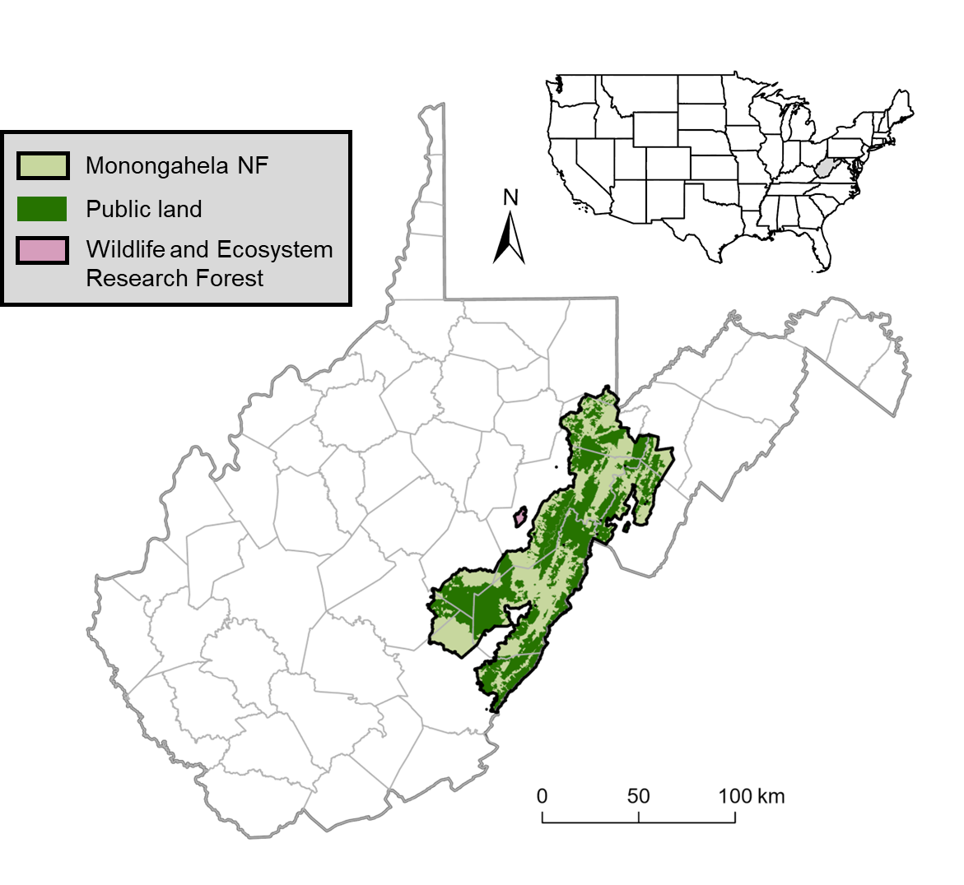

Figure 1. Sampling sites and nest search plots for this study were located in 2 study areas in West Virginia: (1) the MeadWestvaco Wildlife and Ecosystem Research Forest, which was established in 1994 by the Westvaco Corporation and comprises 3,080 ha; and (2) the Monongahela National Forest (NF), which encompasses portions of nine counties (delineated by gray lines) and comprises nearly 688,000 ha, of which 54% (371,906 ha) is public land (dark green).

Figure 2. Locations of the sampling points and nest search plots within the MeadWestvaco Wildlife and Ecosystem Research Forest (WERF) in 1996–1998, 2001–2003, and 2007–2009.

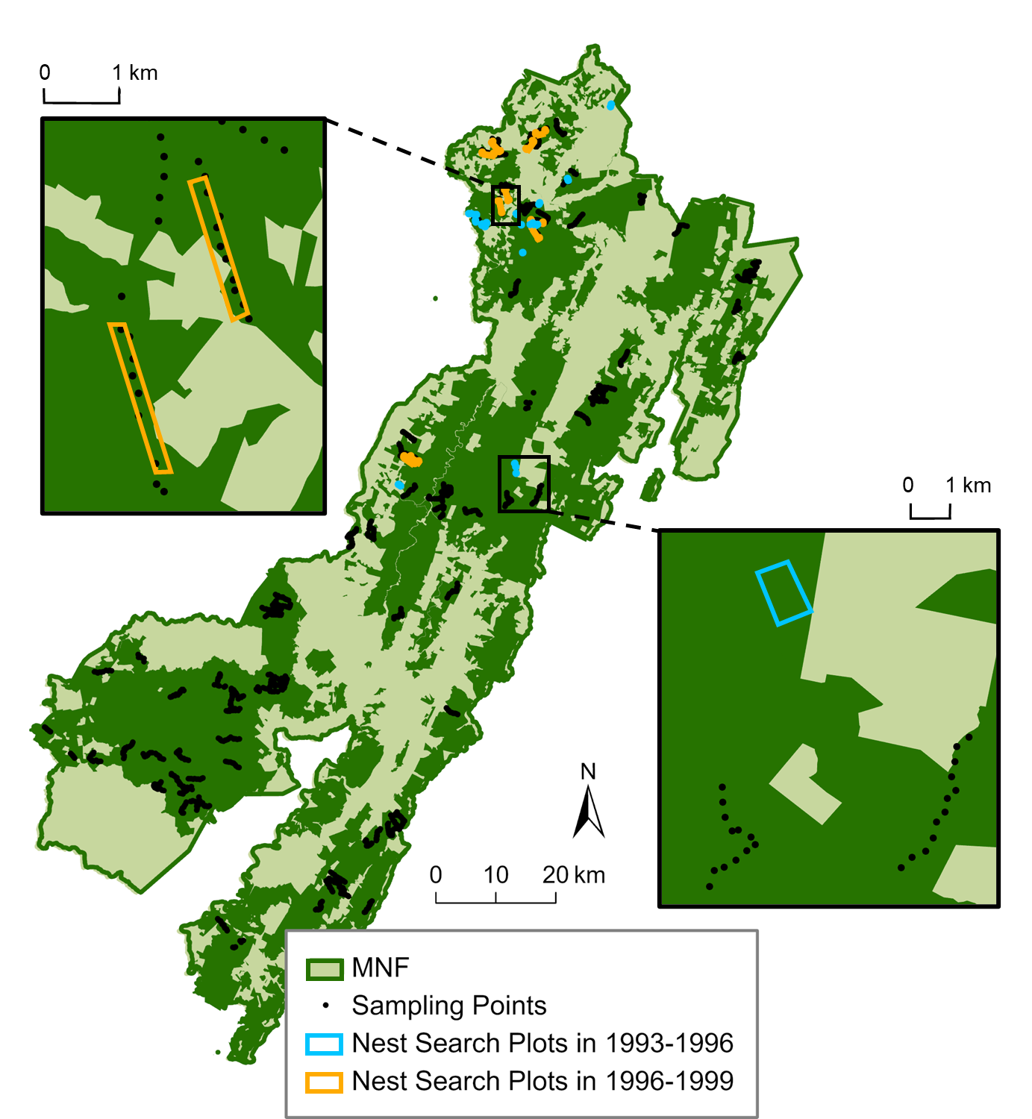

Figure 3. Locations of the sampling points and nest search plots within the public lands (dark green) of the Monongahela National Forest (MNF) in 1993–1996 and 1996–1999.

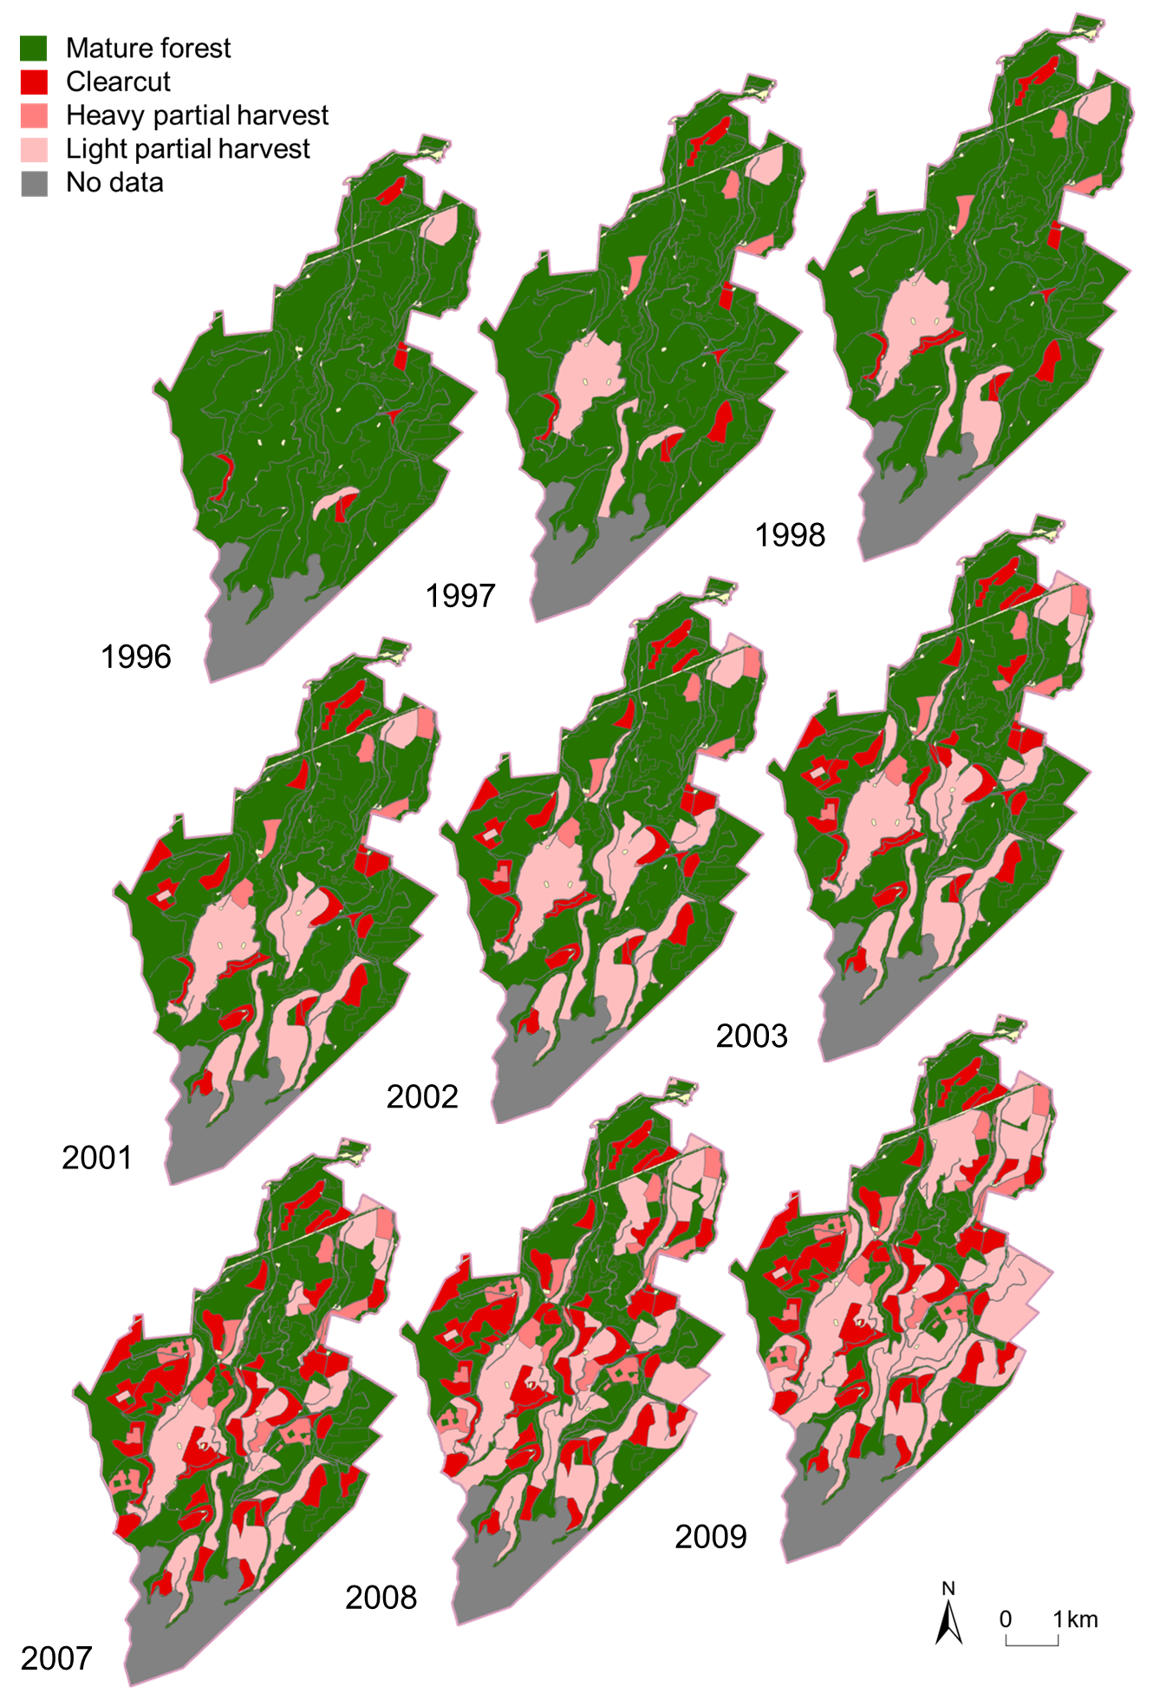

Figure 4. Timber harvest history of the actively harvested MeadWestvaco Wildlife and Ecosystem Research Forest (WERF) during 1996–1998, 2001–2003, and 2007–2009. Heavy partial harvest methods included shelterwood cuts, two-age harvests, and regeneration (seed-tree) harvests, whereas light partial harvest methods included diameter-limit harvests and single-tree selection.

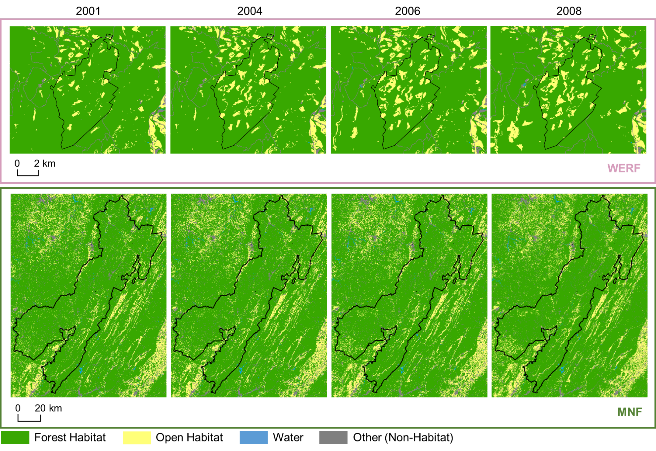

Figure 5. Land cover change in the MeadWestvaco Wildlife and Ecosystem Research Forest (WERF) and the Monongahela National Forest (MNF) from 2001 to 2009, based on 2001 / 2004 / 2006 / 2008 National Land Cover Database (NLCD) data. In these maps, NLCD land cover classifications were aggregated into 4 cover types: mature forest (comprising deciduous, mixed, and coniferous forest), open habitat (representing early-successional habitat and comprising shrubs, grasslands, and hay / pasture), water, and other non-habitat cover (comprising developed land, barren land, and cropland).

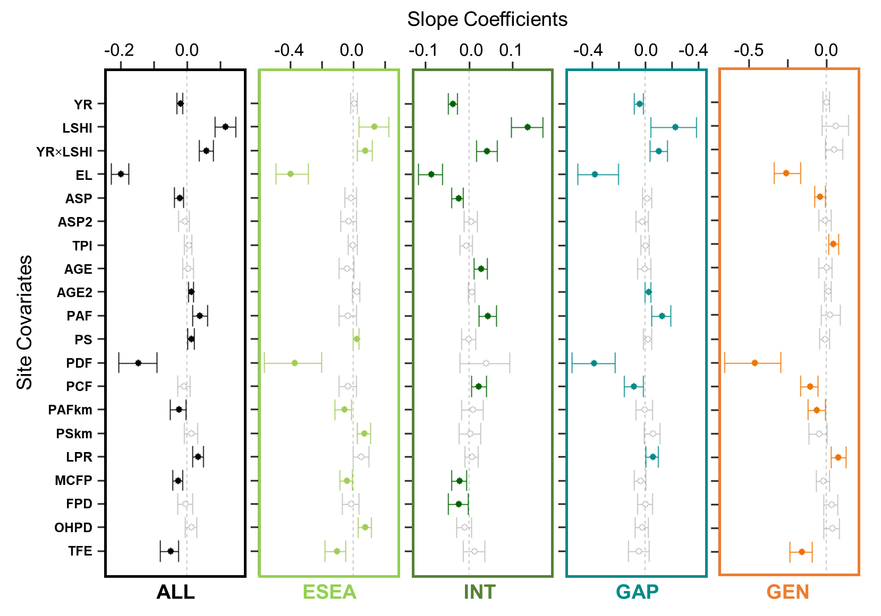

Figure 6. Whisker plots for overall species richness (ALL), guild (early-successional / edge-associated [ESEA], forest-interior [INT], forest-gap [GAP], and forest generalist [GEN]) richness (see Appendix A for guild designations and associated forest songbird species), displaying the slope coefficients of the predictor variables (i.e., site covariates; year [YR], landscape-scale harvest intensity [LSHI], their interaction [YR×LSHI], elevation [EL], aspect [ASP] squared [ASP2], topographic position index [TPI], stand age [AGE] squared [AGE2], proportion of all forest [PAF] / shrub cover [PS] / deciduous forest [PDF] / conifer forest [PCF] within 50 m, proportion of all forest [PAFkm] / shrub cover [PSkm] within 1 km, and landscape patch richness [LPR] / mean core forest patches [MCFP] / forest patch density [FPD] / open habitat patch density [OHPD] / total forest edge [TFE] within 1 km). Points are located at the mean values for the posterior distributions and the corresponding whiskers encompass the 95% credible intervals. Solid colored points with closed circles and non-gray whiskers indicate statistical significance (i.e., credible intervals do not overlap zero).

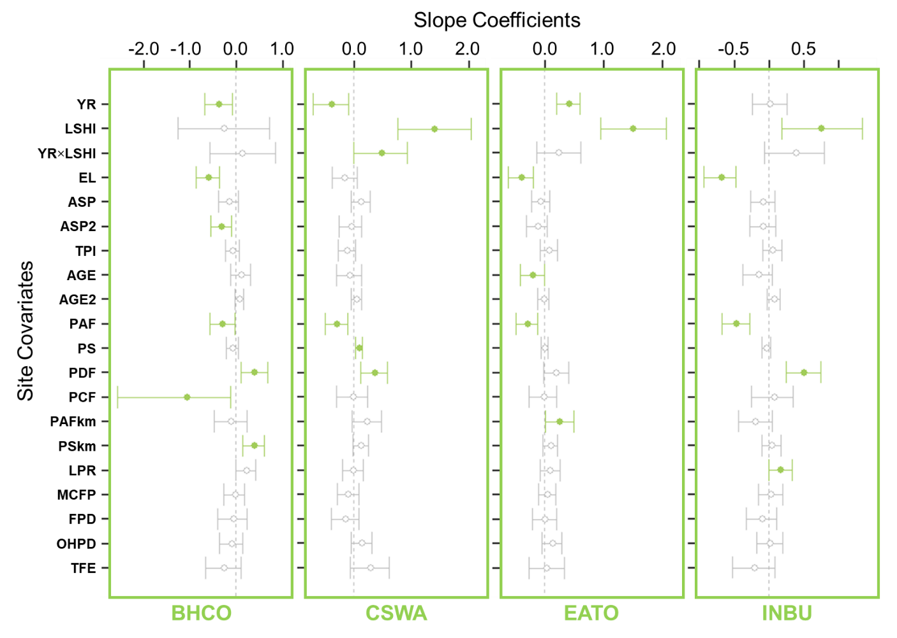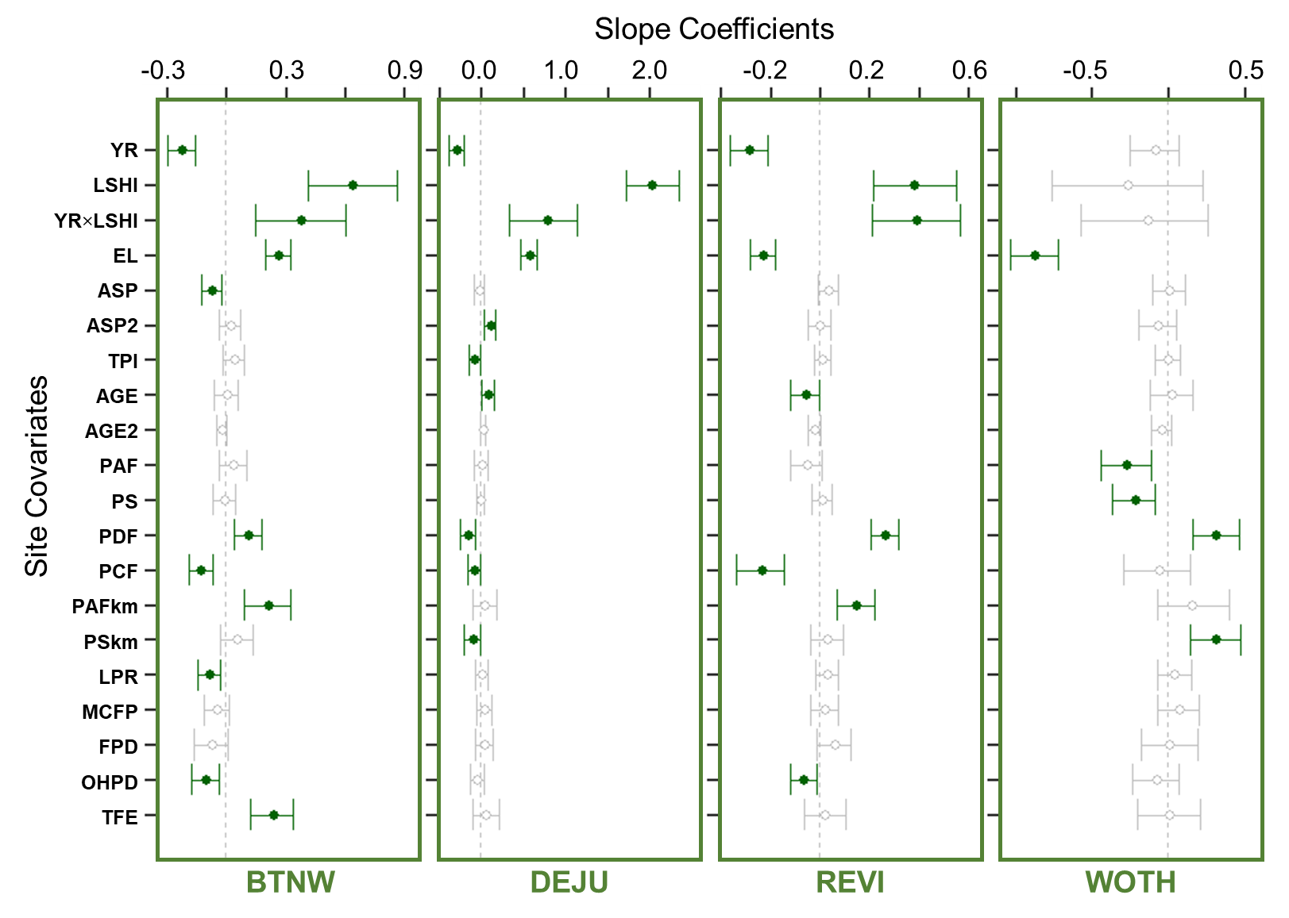

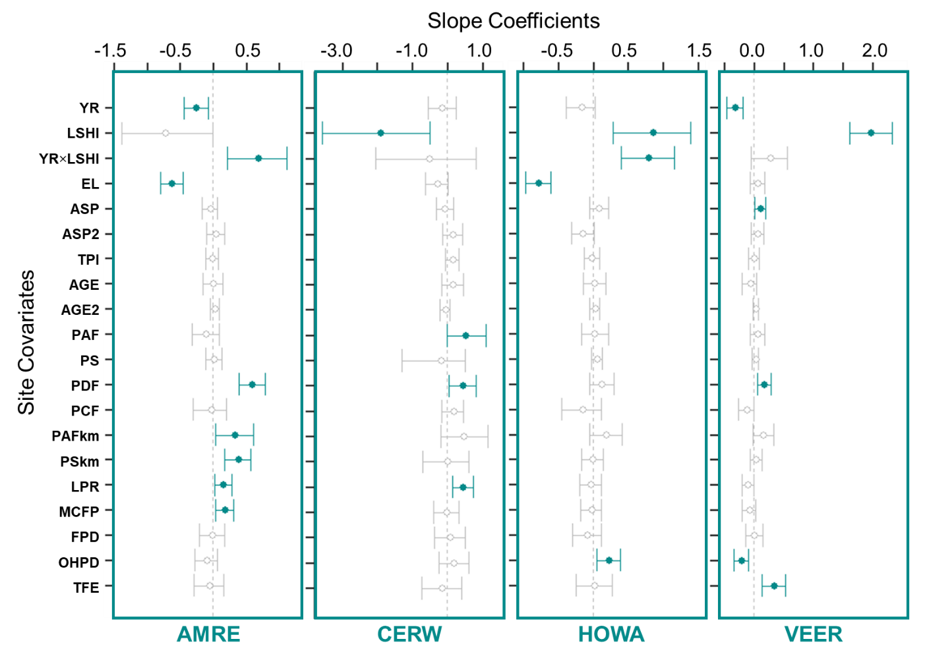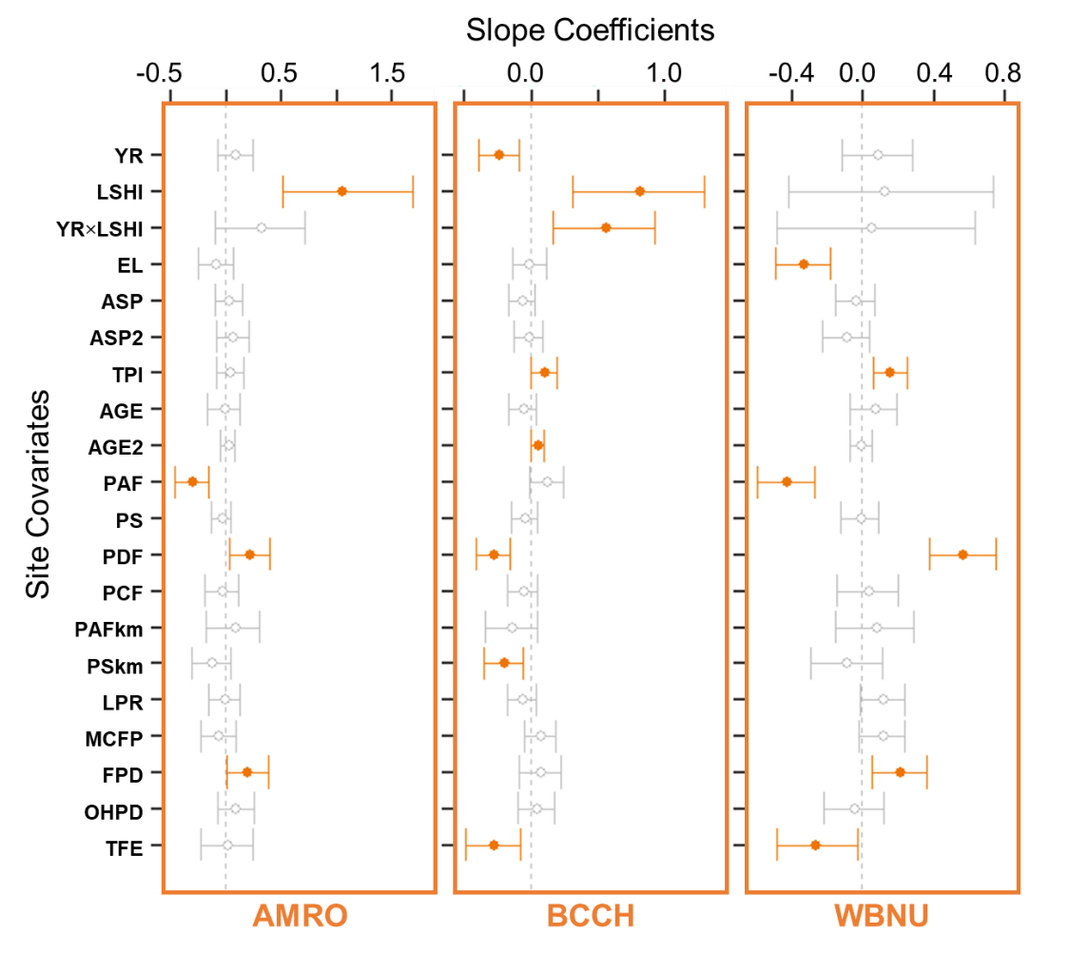

Figure 7. Whisker plots for each focal species for abundance analyses (Table 1), displaying the slope coefficients of the predictor variables (i.e., site covariates; year [YR], landscape-scale harvest intensity [LSHI], their interaction [YR×LSHI], elevation [EL], aspect [ASP] squared [ASP2], topographic position index [TPI], stand age [AGE] squared [AGE2], proportion of all forest [PAF] / shrub cover [PS] / deciduous forest [PDF] / conifer forest [PCF] within 50 m, proportion of all forest [PAFkm] / shrub cover [PSkm] within 1 km, and landscape patch richness [LPR] / mean core forest patches [MCFP] / forest patch density [FPD] / open habitat patch density [OHPD] / total forest edge [TFE] within 1 km). Points are located at the mean values for the posterior distributions and the corresponding whiskers encompass the 95% credible intervals. Solid colored points with closed circles and non-gray whiskers indicate statistical significance (i.e., credible intervals do not overlap zero). Color of the 4-letter species code and plot elements indicates the species’ guild designation (light green = early-successional or edge-associated guild, dark green = forest-interior guild, teal = forest-gap guild, and orange = forest generalist guild).

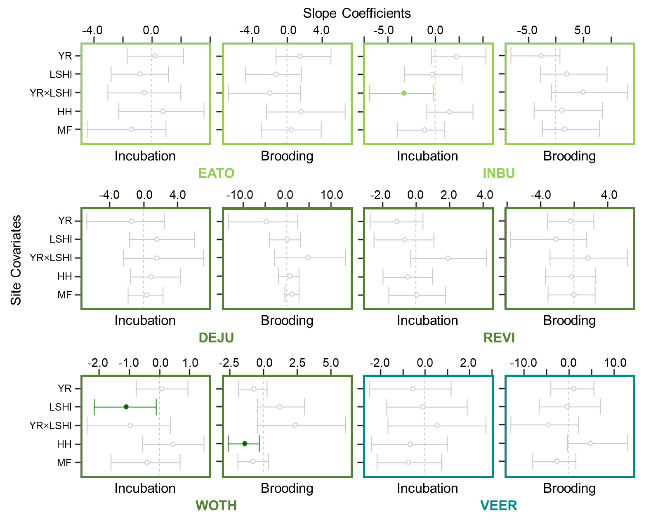

Figure 8. Whisker plots for each focal species for nest success analyses (Table 1), displaying the slope coefficients of the predictor variables (i.e., site covariates; year [YR], landscape-scale harvest intensity [LSHI], interaction [YR×LSHI] between year and landscape-scale harvest intensity, harvest history [HH] of nest search plot, and nest search plot located in mature forest [MF]) for nest success during the incubation and brooding periods, respectively. Points are located at the mean values for the posterior distributions and the corresponding whiskers encompass the 95% credible intervals. Solid colored points with closed circles and non-gray whiskers indicate statistical significance (i.e., credible intervals do not overlap zero). Color of the 4-letter species code and plot elements indicates the species’ guild designation (light green = early-successional or edge-associated guild, dark green = forest-interior guild, teal = forest-gap guild, and orange = forest generalist guild).

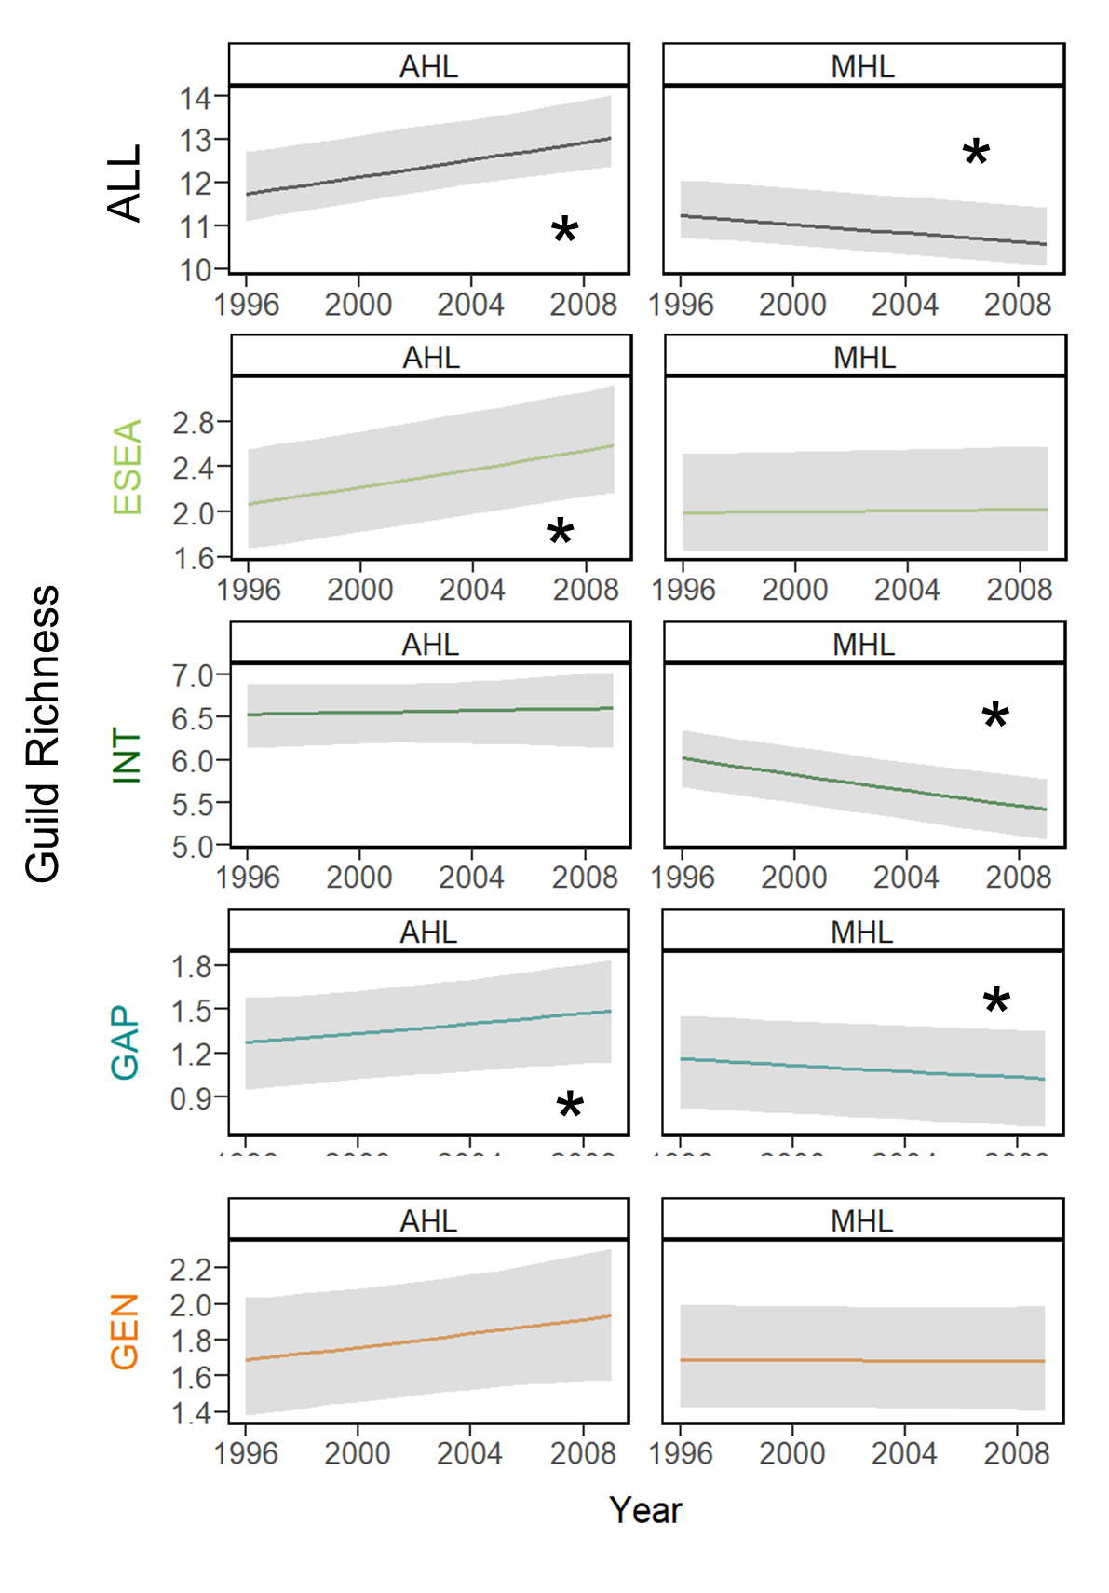

Figure 9. Plots of the change over time in overall species richness (ALL), guild (early-successional / edge-associated [ESEA], forest-interior [INT], forest-gap [GAP], and forest generalist [GEN]) richness (see Appendix A for guild designations and associated forest songbird species) within an actively harvested landscape (AHL) and minimally harvested landscape (MHL). An asterisk indicates a significant trend, where the 95% credible interval of the effective slope coefficient for year does not overlap 0.

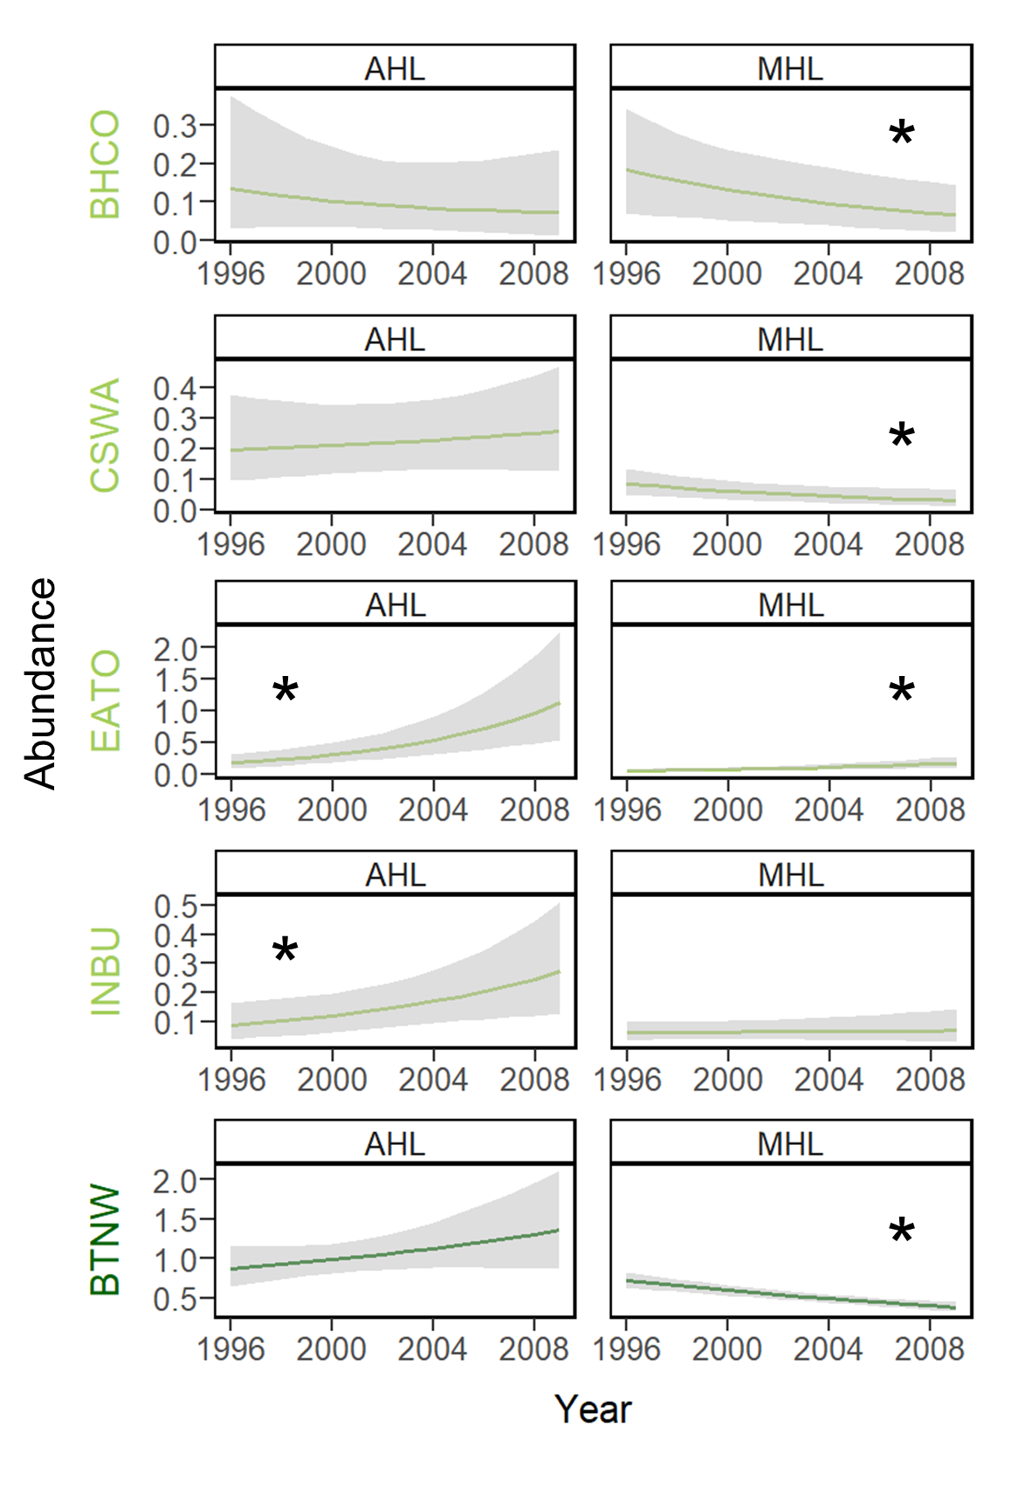

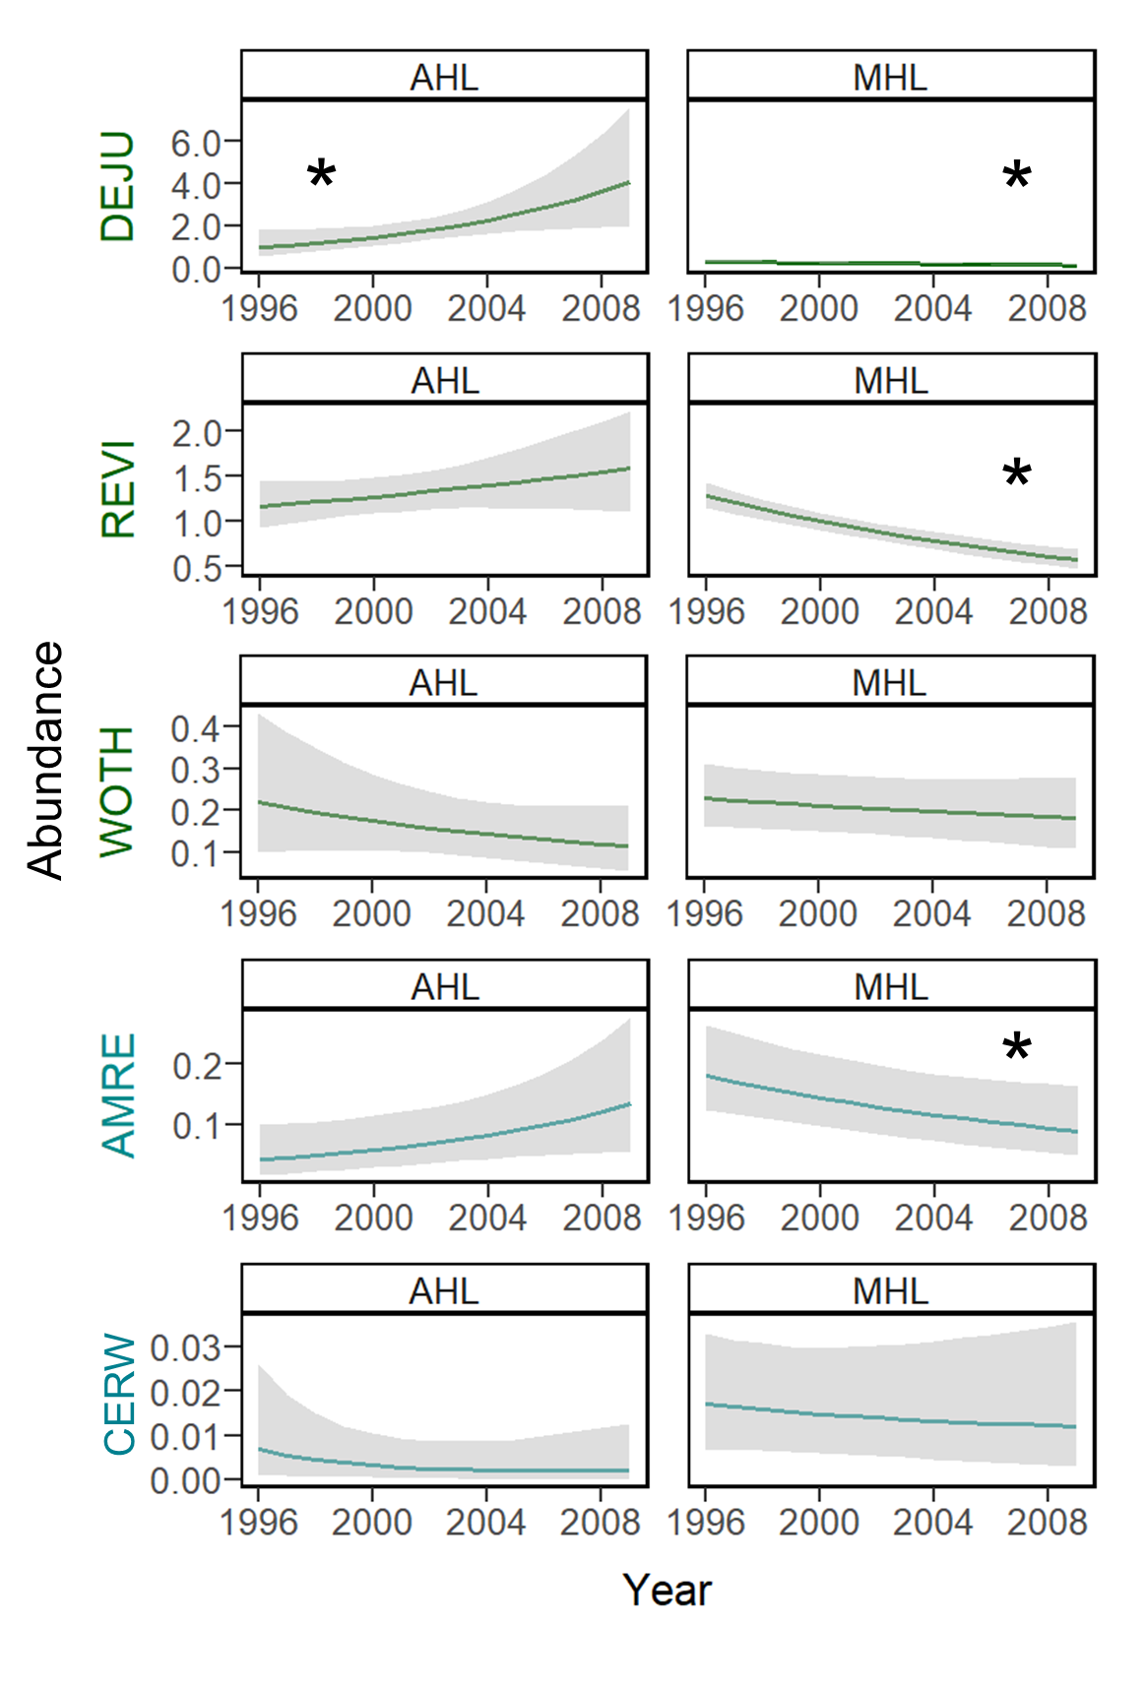

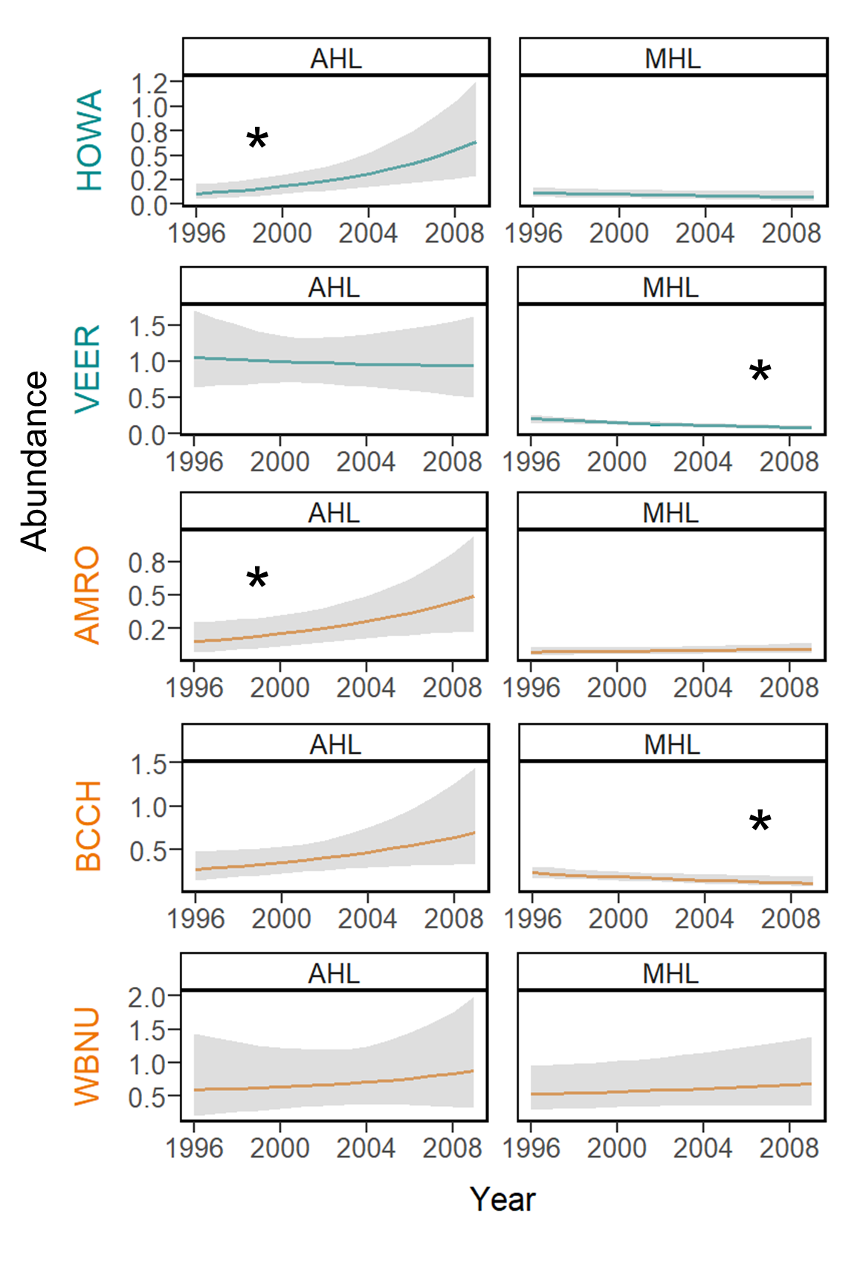

Figure 10. Plots of the change over time in focal songbird species abundance (see Table 1 for species codes) within an actively harvested landscape (AHL) and minimally harvested landscape (MHL). Color of the 4-letter species code and plot elements indicates the species’ guild designation (light green = early-successional or edge-associated guild, dark green = forest-interior guild, teal = forest-gap guild, and orange = forest generalist guild). An asterisk indicates a significant trend, where the 95% credible interval of the effective slope coefficient for year does not overlap 0.

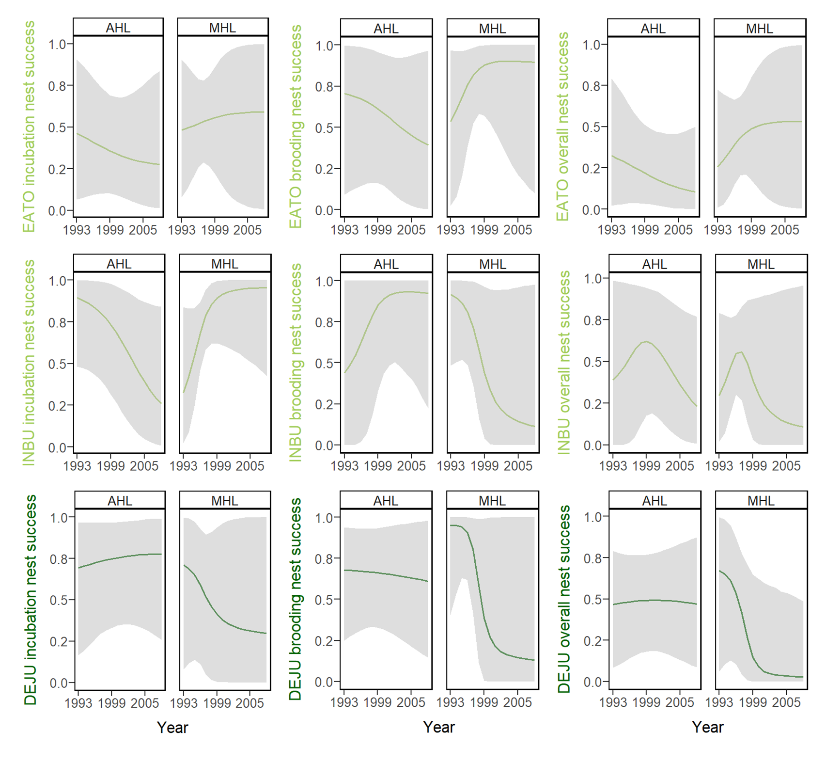

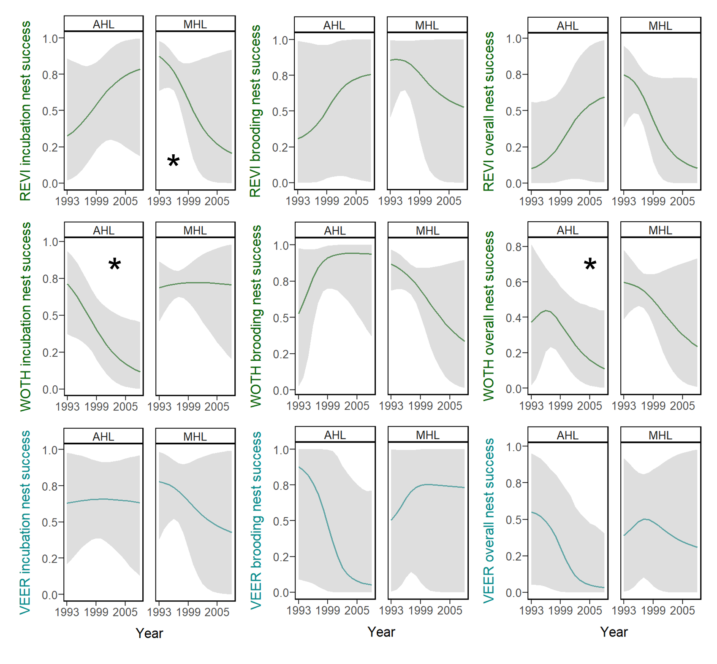

Figure 11. Plots of the change over time in focal songbird species nest success (see Table 1 for species codes) during the incubation period, brooding period, and overall nesting period within an actively harvested landscape (AHL) and minimally harvested landscape (MHL). Color of the 4-letter species code and plot elements indicates the species’ guild designation (light green = early-successional or edge-associated guild, dark green = forest-interior guild, and teal = forest-gap guild). An asterisk indicates a significant trend, where the 95% credible interval of the effective slope coefficient for year does not overlap 0.

**APPENDICES**

**Appendix A**

Table of the 62 passerine and near-passerine species considered in the guild richness analyses.

Table A1. List of the common name, scientific name, 4-letter species code, relative frequency, taxonomic family, habitat-related guild designation, and focal species status of all 62 passerine and near-passerine species considered for the guild richness analyses. Relative frequency is the number of detections across all breeding bird point count surveys from all sampling points in the study. The habitat-related guild designation indicates the primary breeding habitat of the species, such that: species in the early-successional / edge-associated (ESEA) guild breed in open habitat, shrub/scrub, or young forest, or along forest edges, such as the interface of early-successional and mature forest; species in the forest-interior (INT) guild breed in the core area of mature forest; species in the forest-gap (GAP) guild breed in or near small forest gaps within the core area of mature forest; and species in the forest generalist (GEN) guild are associated with forest but have no preference for early-successional vs. mature forest.

|  |  |  |  |  |  |
| --- | --- | --- | --- | --- | --- |
| **Common Name**  **(*Scientific Name*)** | **Species Code** | **Relative Frequency** | **Taxonomic Family** | **Guild** | **Focal Species** |
| Brown-headed Cowbird  (*Molothrus ater*) | BHCO | 163 | Icteridae | ESEA | 1 |
| Chestnut-sided Warbler  (*Setophaga pensylvanica*) | CSWA | 600 | Parulidae | ESEA | 1 |
| Eastern Towhee  (*Pipilo erythrophthalmus*) | EATO | 718 | Passerellidae | ESEA | 1 |
| Indigo Bunting  (*Passerina cyanea*) | INBU | 589 | Cardinalidae | ESEA | 1 |
| American Goldfinch  (*Spinus tristis*) | AMGO | 89 | Fringillidae | ESEA | 0 |
| Blue-winged Warbler  (*Vermivora cyanoptera*) | BWWA | 110 | Parulidae | ESEA | 0 |
| Carolina Wren  (*Thryothorus ludovicianus*) | CARW | 14 | Troglodytidae | ESEA | 0 |
| Cedar Waxwing  (*Bombycilla cedrorum*) | CEDW | 216 | Bombycillidae | ESEA | 0 |
| Chipping Sparrow  (*Spizella passerina*) | CHSP | 40 | Passerellidae | ESEA | 0 |
| Common Yellowthroat  (*Geothlypis trichas*) | COYE | 60 | Parulidae | ESEA | 0 |
| Eastern Phoebe  (*Sayornis phoebe*) | EAPH | 16 | Tyrannidae | ESEA | 0 |

Table A1. Continued.

|  |  |  |  |  |  |
| --- | --- | --- | --- | --- | --- |
| **Common Name**  **(*Scientific Name*)** | **Species Code** | **Relative Frequency** | **Taxonomic Family** | **Guild** | **Focal Species** |
| Field Sparrow  (*Spizella pusilla*) | FISP | 34 | Passerellidae | ESEA | 0 |
| Gray Catbird  (*Dumetella carolinensis*) | GRCA | 132 | Mimidae | ESEA | 0 |
| Mourning Dove  (*Zenaida macroura*) | MODO | 17 | Columbidae | ESEA | 0 |
| Mourning Warbler  (*Geothlypis philadelphia*) | MOWA | 42 | Parulidae | ESEA | 0 |
| Northern Cardinal  (*Cardinalis cardinalis*) | NOCA | 24 | Cardinalidae | ESEA | 0 |
| Song Sparrow  (*Melospiza melodia*) | SOSP | 75 | Passerellidae | ESEA | 0 |
| Yellow-billed Cuckoo  (*Coccyzus americanus*) | YBCU | 64 | Cuculidae | ESEA | 0 |
| Black-throated Green Warbler  (*Setophaga virens*) | BTNW | 2458 | Parulidae | INT | 1 |
| Dark-eyed Junco  (*Junco hyemalis*) | DEJU | 1719 | Passerellidae | INT | 1 |
| Red-eyed Vireo  (*Vireo olivaceus*) | REVI | 3135 | Vireonidae | INT | 1 |
| Wood Thrush  (*Hylocichla mustelina*) | WOTH | 610 | Turdidae | INT | 1 |
| Acadian Flycatcher  (*Empidonax virescens*) | ACFL | 708 | Tyrannidae | INT | 0 |
| Black-and-white Warbler  (*Mniotilta varia*) | BAWW | 641 | Parulidae | INT | 0 |
| Blackburnian Warbler  (*Setophaga fusca*) | BLBW | 608 | Parulidae | INT | 0 |
| Black-throated Blue Warbler  (*Setophaga caerulescens*) | BTBW | 1162 | Parulidae | INT | 0 |
| Blue-headed Vireo  (*Vireo solitarius*) | BHVI | 1636 | Vireonidae | INT | 0 |
| Brown Creeper  (*Certhia americana*) | BRCR | 150 | Certhiidae | INT | 0 |
| Canada Warbler  (*Cardellina canadensis*) | CAWA | 558 | Parulidae | INT | 0 |
| Golden-crowned Kinglet  (*Regulus satrapa*) | GCKI | 437 | Regulidae | INT | 0 |
| Hairy Woodpecker  (*Leuconotopicus villosus*) | HAWO | 318 | Picidae | INT | 0 |
| Hermit Thrush  (*Catharus guttatus*) | HETH | 384 | Turdidae | INT | 0 |

Table A1. Continued.

|  |  |  |  |  |  |
| --- | --- | --- | --- | --- | --- |
| **Common Name**  **(*Scientific Name*)** | **Species Code** | **Relative Frequency** | **Taxonomic Family** | **Guild** | **Focal Species** |
| Least Flycatcher  (*Empidonax minimus*) | LEFL | 71 | Tyrannidae | INT | 0 |
| Magnolia Warbler  (*Setophaga magnolia*) | MAWA | 1153 | Parulidae | INT | 0 |
| Ovenbird  (*Seiurus aurocapilla*) | OVEN | 788 | Parulidae | INT | 0 |
| Pileated Woodpecker  (*Dryocopus pileatus*) | PIWO | 168 | Picidae | INT | 0 |
| Pine Warbler  (*Setophaga pinus*) | PIWA | 79 | Parulidae | INT | 0 |
| Purple Finch  (*Haemorhous purpureus*) | PUFI | 35 | Fringillidae | INT | 0 |
| Red-breasted Nuthatch  (*Sitta canadensis*) | RBNU | 198 | Sittidae | INT | 0 |
| Rose-breasted Grosbeak  (*Pheucticus ludovicianus*) | RBGR | 443 | Cardinalidae | INT | 0 |
| Scarlet Tanager  (*Piranga olivacea*) | SCTA | 1084 | Cardinalidae | INT | 0 |
| Swainson's Thrush  (*Catharus ustulatus*) | SWTH | 126 | Turdidae | INT | 0 |
| Winter Wren  (*Troglodytes hiemalis*) | WIWR | 541 | Troglodytidae | INT | 0 |
| Worm-eating Warbler  (*Helmitheros vermivorum*) | WEWA | 237 | Parulidae | INT | 0 |
| Yellow-rumped Warbler  (*Setophaga coronata*) | YRWA | 83 | Parulidae | INT | 0 |
| American Redstart  (*Setophaga ruticilla*) | AMRE | 568 | Parulidae | GAP | 1 |
| Cerulean Warbler  (*Setophaga cerulea*) | CERW | 125 | Parulidae | GAP | 1 |
| Hooded Warbler  (*Setophaga citrina*) | HOWA | 580 | Parulidae | GAP | 1 |
| Veery  (*Catharus fuscescens*) | VEER | 1070 | Turdidae | GAP | 1 |
| Eastern Wood-Pewee  (*Contopus virens*) | EAWP | 314 | Tyrannidae | GAP | 0 |
| Great-crested Flycatcher  (*Myiarchus crinitus*) | GCFL | 90 | Tyrannidae | GAP | 0 |
| Northern Parula  (*Setophaga americana*) | NOPA | 113 | Parulidae | GAP | 0 |
| Yellow-throated Vireo  (*Vireo flavifrons*) | YTVI | 44 | Vireonidae | GAP | 0 |

Table A1. Continued.

|  |  |  |  |  |  |
| --- | --- | --- | --- | --- | --- |
| **Common Name**  **(*Scientific Name*)** | **Species Code** | **Relative Frequency** | **Taxonomic Family** | **Guild** | **Focal Species** |
| American Robin  (*Turdus migratorius*) | AMRO | 533 | Turdidae | GEN | 1 |
| Black-capped Chickadee  (*Poecile atricapillus*) | BCCH | 702 | Paridae | GEN | 1 |
| White-breasted Nuthatch  (*Sitta carolinensis*) | WBNU | 449 | Sittidae | GEN | 1 |
| Blue-gray Gnatcatcher  (*Polioptila caerulea*) | BGGN | 147 | Polioptilidae | GEN | 0 |
| Downy Woodpecker  (*Picoides pubescens*) | DOWO | 206 | Picidae | GEN | 0 |
| Northern Flicker  (*Colaptes auratus*) | NOFL | 134 | Picidae | GEN | 0 |
| Red-bellied Woodpecker  (*Melanerpes carolinus*) | RBWO | 51 | Picidae | GEN | 0 |
| Tufted Titmouse  (*Baeolophus bicolor*) | TUTI | 195 | Paridae | GEN | 0 |
| Yellow-bellied Sapsucker  (*Sphyrapicus varius*) | YBSA | 24 | Picidae | GEN | 0 |

**Appendix B**

JAGS model code for the guild richness analyses.

model {

### PRIORS

# COMMUNITY-LEVEL MODEL PARAMETERS (OCCUPANCY)

community.occupancy.a ~ dlogis(0,1) #this assumes a logistic prior

community.occupancy.tau ~ dgamma(0.1, 0.1)

# COMMUNITY-LEVEL MODEL PARAMETERS (DETECTION)

community.detection.b ~ dlogis(0,1) #this assumes a logistic prior

community.detection.tau ~ dgamma(0.1, 0.1)

# COMMUNITY-LEVEL PARAMETERS FOR SITE COVARIATE SLOPE COEFFICIENTS

for (sitecov in 1:n.sitecovs) {

mu.alpha[sitecov] ~ dnorm(0, 0.1)

tau.alpha[sitecov] ~ dgamma(0.1, 0.1)

}

# COMMUNITY-LEVEL PARAMETERS FOR DETECTION COVARIATE SLOPE COEFFICIENTS

for (detcov in 1:n.detcovs) {

mu.beta[detcov] ~ dnorm(0, 0.1)

tau.beta[detcov] ~ dgamma(0.1, 0.1)

}

# SPECIES-SPECIFIC PRIORS FROM THE COMMUNITY-LEVEL PRIOR DISTRIBUTIONS

for (spp in 1:n.species) {

# INTERCEPTS

alpha0[spp] ~ dnorm(community.occupancy.a, community.occupancy.tau)

beta0[spp] ~ dnorm(community.detection.b, community.detection.tau)

# SLOPE COEFFICIENTS FOR SITE COVARIATES

for (sitecov in 1:n.sitecovs) {

alpha[spp, sitecov] ~ dnorm(mu.alpha[sitecov], tau.alpha[sitecov])

}

# RANDOM SITE EFFECT

tau.rse[spp] ~ dgamma(0.1, 0.1)

for (site in 1:n.sites) {

random.site.effect[spp, site] ~ dnorm(alpha0[spp], tau.rse[spp])

}

# SLOPE COEFFICIENTS FOR DETECTION COVARIATES

for (detcov in 1:n.detcovs) {

beta[spp, detcov] ~ dnorm(mu.beta[detcov], tau.beta[detcov])

}

# RANDOM OBSERVER EFFECT

tau.roe[spp] ~ dgamma(0.1, 0.1)

for (observer in 1:n.observers) {

random.observer.effect[spp, observer] ~ dnorm(beta0[spp], tau.roe[spp])

}

} # NOTES: Loop over all species.

# PARAMETERS FOR IMPUTATION OF DETECTION COVARIATES (WIND CODE AND SKY CODE)

wind.prob ~ dbeta(1, 1)

sky.prob ~ dbeta(1, 1)

### LIKELIHOOD

# IMPUTATION OF DETECTION COVARIATES

for (site in 1:n.sites){

for (year in 1:n.years[site]) {

for (replicate in 1:n.replicates[site, year]) {

time.array[site, year, replicate] ~ dnorm(0, 1)

wind.array[site, year, replicate] ~ dbern(wind.prob)

sky.array[site, year, replicate] ~ dbern(sky.prob)

}

}

}

# NOTES: Loop over sites, years, and replicates.

# Loop to estimate the Z matrix (true occurrence) for each species at each

# site

for (spp in 1:n.species) {

for (site in 1:n.sites){

for (year in 1:n.years[site]) {

# OCCUPANCY MODEL

logit(psi[site, year, spp]) <- inprod(alpha[spp, 1:n.sitecovs],

sitecov.array[site, year, 1:n.sitecovs]) +

random.site.effect[spp, site]

# ESTIMATING OCCUPANCY

Z[site, year, spp] ~ dbern(psi[site, year, spp])

# Loop to estimate detection of each species at each site during

# each sampling replicate

for (replicate in 1:n.replicates[site, year]) {

# DETECTION MODEL

logit(p[site, year, replicate, spp]) <-

beta[spp, 1] * day.array[site, year, replicate] +

beta[spp, 2] * time.array[site, year, replicate] +

beta[spp, 3] * time.array[site, year, replicate] *

time.array[site, year, replicate] +

beta[spp, 4] * wind.array[site, year, replicate] +

beta[spp, 5] * sky.array[site, year, replicate] +

random.observer.effect[spp,

observer.id.array[site, year, replicate]]

# ESTIMATING PROBABILITY OF DETECTION

mu.p[site, year, replicate, spp] <- p[site, year, replicate, spp]

* Z[site, year, spp]

Y[site, year, replicate, species] ~ dbern(mu.p[site, year,

replicate, species])

} # end replicate loop

} #end year loop

} #end site loop

} #end species loop

### DERIVED QUANTITIES

# Loop to determine site-level richness estimates for the whole community

# and for subsets or assemblages of interest

for (site in 1:n.sites) {

for (year in 1:n.years[site]) {

overall.species.richness[site, year] <- sum(Z[site, year, 1:n.species])

ESEA.guild.richness[site, year] <- inprod(Z[site, year, 1:n.species],

es.ea.guild[1:n.species])

INT.guild.richness[site, year] <- inprod(Z[site, year, 1:n.species],

forest.interior.guild[1:n.species])

GAP.guild.richness[site, year] <- inprod(Z[site, year, 1:n.species],

forest.gap.guild[1:n.species])

GEN.guild.richness[site, year] <- inprod(Z[site, year, 1:n.species],

forest.generalist.guild[1:n.species])

}

} #end site loop

}

**Appendix C**

JAGS model code for the focal species abundance analyses.

model {

### PRIORS

for (spp in 1:n.species) {

# INTERCEPTS

alpha0[spp] ~ dnorm(0, 0.1) #intercept for abundance model

beta0[spp] ~ dnorm(0, 0.1) #intercept for detection model

# SLOPE COEFFICIENTS FOR SITE COVARIATES

for (alpha.index in 1:n.alphas) {

alpha[spp, alpha.index] ~ dnorm(0, 0.1)

}

# RANDOM SITE EFFECT

tau.rse[spp] ~ dgamma(0.1, 0.1) #for random site effects

for (site in 1:n.sites){

random.site.effect[spp, site] ~ dnorm(alpha0[spp], tau.rse[spp])

}

# NOTES: Loop over the number of unique sites

# SLOPE COEFFICIENTS FOR DETECTION COVARIATES

for (detcov in 1:n.detcovs) {

beta[species, detcov] ~ dnorm(0, 0.1)

}

# RANDOM OBSERVER EFFECT

tau.roe[spp] ~ dgamma(0.1, 0.1)

for (observer in 1:n.observers) {

random.observer.effect[spp, observer] ~ dnorm(beta0[spp], tau.roe[spp])

}

}

# NOTES: Loop over each focal species.

# PARAMETERS FOR IMPUTATION OF DETECTION COVARIATES (WIND CODE AND SKY CODE)

wind.prob ~ dbeta(1, 1)

sky.prob ~ dbeta(1, 1)

### LIKELIHOOD

# IMPUTATION OF DETECTION COVARIATES

for (site in 1:n.sites){

for (year in 1:n.years[site]) {

for (visit in 1:n.visits[site, year]) {

time.array[site, year, visit] ~ dnorm(0, 1)

wind.array[site, year, visit] ~ dbern(wind.prob)

sky.array[site, year, visit] ~ dbern(sky.prob)

}

}

}

# NOTES: Loop over sites, years, and visits.

# ESTIMATE ABUNDANCE AND DETECTION PROBABILITY

for (spp in 1:n.species) {

# Loop to estimate N (true abundance) for each species at each site

for (site in 1:n.sites) {

for (year in 1:n.years[site]) {

# ABUNDANCE MODEL

log(lambda[site, year, spp]) <- inprod(alpha[spp, 1:n.sitecovs],

sitecov.array[site, year, 1:n.sitecovs]) +

random.site.effect[spp, site]

# ESTIMATING ABUNDANCE

N[site, year, spp] ~ dpois(lambda[site, year, spp])

for (visit in 1:n.visits[site, year]) {

# OBSERVATION PROBABILITY

Y[site, year, visit, 1, spp] ~ dbin(p[site, year, visit, 1, spp],

N[site, year, spp])

z[site, year, visit, 1, spp] <- N[site, year, spp] –

Y[site, year, visit, 1, spp]

for (i in 2:n.replicates) {

Y[site, year, visit, i, spp] ~ dbin(p[site, year, visit, i, spp],

z[site, year, visit, i-1, spp])

z[site, year, visit, i, spp] <- N[site, year, spp] –

sum(Y[site, year, visit, 1:i, spp])

}

# Loop to estimate detection each species at each site

for (replicate in 1:n.replicates) {

# DETECTION MODEL

logit(p[site, year, visit, replicate, spp]) <-

beta[spp, 1] * day.array[site, year, visit] +

beta[spp, 2] * time.array[site, year, visit] +

beta[spp, 3] * time.array[site, year, visit] *

time.array[site, year, visit] +

beta[spp, 4] * wind.array[site, year, visit] +

beta[spp, 5] * sky.array[site, year, visit] +

random.observer.effect[spp,

observer.id.array[site, year, visit]]

}

# NOTES: Loop over each replicate for each site.

} # end visit loop

} # end year loop

} # end site loop

} # end species loop

}

**Appendix D**

Table of model information for overall species richness, the 4 habitat-related guild designations considered in the guild richness analyses, the 15 focal songbird species considered in the abundance analyses, and the 6 focal songbird species considered in the nest success analyses.

Table D1. List of the 4 habitat-related guild designations and 15 focal songbird species (see Table 1 for species codes), with corresponding information for the hierarchical community model (HCM), focal species abundance (FSA) models, and focal species nest success (FSNS) models that includes the number of chains (Chains), total iterations (Total), burn-in (Burn), thinning rate (Thin), and resulting posterior iterations (Posterior). The habitat-related guild designation indicates the primary breeding habitat of the species (see Appendix A for precise definitions) and includes 4 categories: early-successional / edge-associated (ESEA), forest-interior (INT), forest-gap (GAP), and forest generalist (GEN).

|  |  |  |  |  |  |  |  |
| --- | --- | --- | --- | --- | --- | --- | --- |
| **Guild** | **Species** | **Model** | **Chains** | **Total** | **Burn-In** | **Thin** | **Posterior** |
| ALL |  | HCM | 3 | 7,000 | 5,000 | 2 | 3,000 |
| ESEA | | HCM | 3 | 7,000 | 5,000 | 2 | 3,000 |
|  | BHCO | FSA | 3 | 63,000 | 54,000 | 3 | 9,000 |
|  | CSWA | FSA | 3 | 24,000 | 15,000 | 3 | 9,000 |
|  | EATO | FSA | 3 | 38,000 | 29,000 | 3 | 9,000 |
|  |  | FSNS | 3 | 12,000 | 6,000 | 3 | 6,000 |
|  | INBU | FSA | 3 | 19,000 | 10,000 | 3 | 9,000 |
|  |  | FSNS | 3 | 30,000 | 21,000 | 3 | 9,000 |
| INT | | HCM | 3 | 7,000 | 5,000 | 2 | 3,000 |
|  | BTNW | FSA | 3 | 12,000 | 9,000 | 3 | 3,000 |
|  | DEJU | FSA | 3 | 12,000 | 9,000 | 3 | 3,000 |
|  |  | FSNS | 3 | 15,000 | 6,000 | 3 | 9,000 |
|  | REVI | FSA | 3 | 12,000 | 9,000 | 3 | 3,000 |
|  |  | FSNS | 3 | 12,000 | 6,000 | 3 | 6,000 |
|  | WOTH | FSA | 3 | 24,000 | 15,000 | 3 | 9,000 |
|  |  | FSNS | 3 | 9,000 | 3,000 | 3 | 6,000 |
| GAP | | HCM | 3 | 7,000 | 5,000 | 2 | 3,000 |
|  | AMRE | FSA | 3 | 19,000 | 10,000 | 3 | 9,000 |
|  | CERW | FSA | 3 | 63,000 | 54,000 | 3 | 9,000 |
|  | HOWA | FSA | 3 | 19,000 | 10,000 | 3 | 9,000 |
|  | VEER | FSA | 3 | 12,000 | 9,000 | 3 | 3,000 |
|  |  | FSNS | 3 | 12,000 | 6,000 | 3 | 6,000 |
| GEN | | HCM | 3 | 7,000 | 5,000 | 2 | 3,000 |
|  | AMRO | FSA | 3 | 36,000 | 30,000 | 3 | 6,000 |
|  | BCCH | FSA | 3 | 38,000 | 29,000 | 3 | 9,000 |
|  | WBNU | FSA | 3 | 36,000 | 30,000 | 3 | 6,000 |

**Appendix E**

JAGS model code for the focal species nest success analyses.

model {

### PRIORS

# INTERCEPTS

ISM.alpha0 ~ dnorm(0, 0.01) #intercept for incubation success model (ISM)

BSM.alpha0 ~ dnorm(0, 0.01) #intercept for brooding success model (BSM)

# SLOPE COEFFICIENTS FOR SITE COVARIATES

for (alpha.index in 1:n.alphas) {

ISM.alpha[alpha.index] ~ dnorm(0, 0.01) #for incubation success model

BSM.alpha[alpha.index] ~ dnorm(0, 0.01) #for brooding success model

}

# RANDOM PLOT EFFECT

ISM.tau.rpe ~ dgamma(0.01, 0.01) #for incubation success model

BSM.tau.rpe ~ dgamma(0.01, 0.01) #for brooding success model

for (nest.plot in 1:n.nest.plots){

ISM.random.plot.effect[nest.plot] ~ dnorm(ISM.alpha0, ISM.tau.rpe)

BSM.random.plot.effect[nest.plot] ~ dnorm(BSM.alpha0, BSM.tau.rpe)

}

# NOTES: Loop over the number of nest search plots

### LIKELIHOOD

for (nest in 1:n.nests){

Y[nest, 1] ~ dbern(p.incubation[nest])

Y[nest, 2] ~ dbern(p.brooding[nest] * Y[nest, 1])

# NOTE: probability of nest success during brooding period is conditional

# on nest success during incubation period

logit(p.incubation[nest]) <- ISM.alpha[1] * sitecov.matrix[nest, 1] +

ISM.alpha[2] * sitecov.matrix[nest, 2] +

ISM.alpha[3] * sitecov.matrix[nest, 3] +

ISM.alpha[4] * sitecov.matrix[nest, 4] +

ISM.alpha[5] * sitecov.matrix[nest, 1] *

sitecov.matrix[nest, 2] +

ISM.random.plot.effect[nest.plot.index[nest]]

# sitecov.matrix: 1 = study area, 2 = year, 3 = nest search plot with

# harvest history, 4 = nest search plot in mature forest

logit(p.brooding[nest]) <- BSM.alpha[1] * sitecov.matrix[nest, 1] +

BSM.alpha[2] * sitecov.matrix[nest, 2] +

BSM.alpha[3] * sitecov.matrix[nest, 3] +

BSM.alpha[4] * sitecov.matrix[nest, 4] +

BSM.alpha[5] * sitecov.matrix[nest, 1] *

sitecov.matrix[nest, 2] +

BSM.random.plot.effect[nest.plot.index[nest]]

# sitecov.matrix: 1 = study area, 2 = year, 3 = nest search plot with

# harvest history, 4 = nest search plot in mature forest

p.overall[nest] <- p.incubation[nest] * p.brooding[nest]

} # end nest loop

}